**Advanced Java:**

**Pre-requisites:**

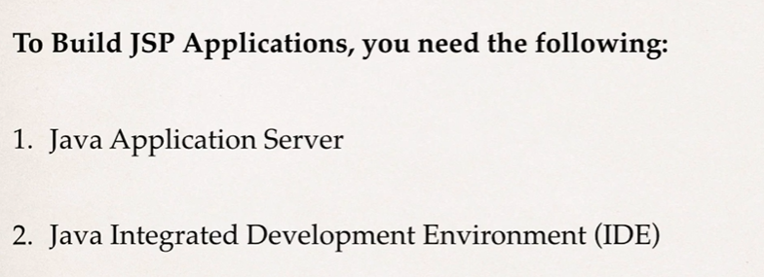

**Tomcat installation:**



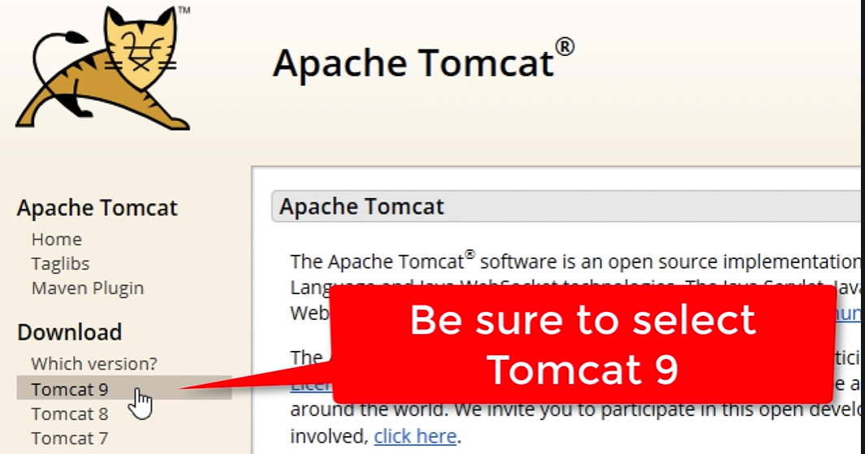

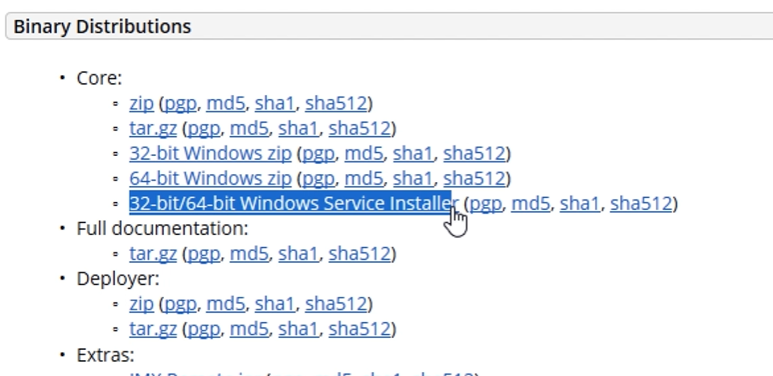

**Download 🡪 go to download location and double click on the file.**

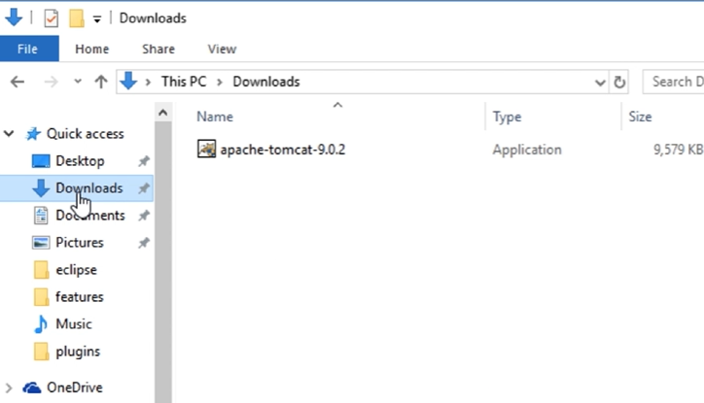

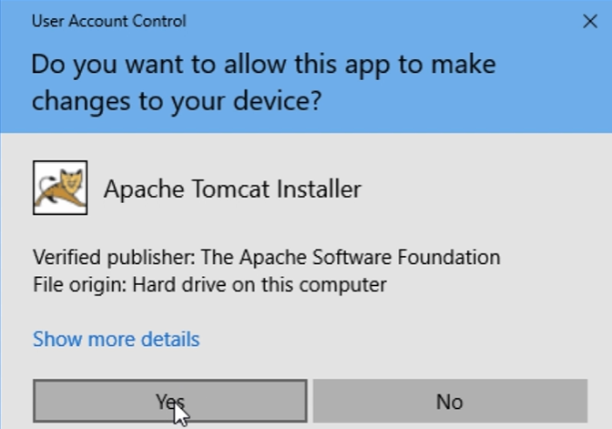

**Yes 🡪 Next 🡪 Agree 🡪 select Full**

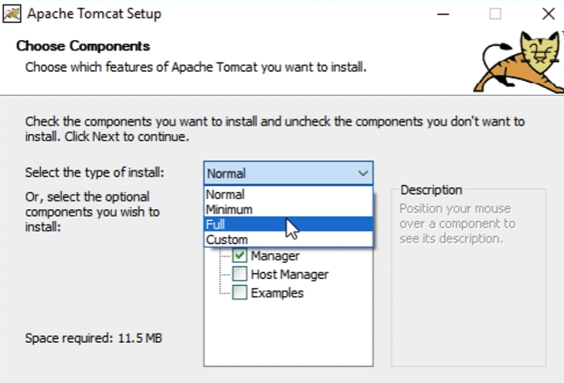

**Make sure all check boxes are ticked.**

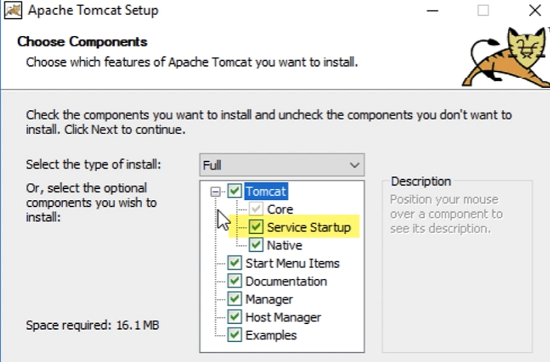

**Click Next and enter PORT details if missing and give username/passwork: admin/admin 🡪 Next**

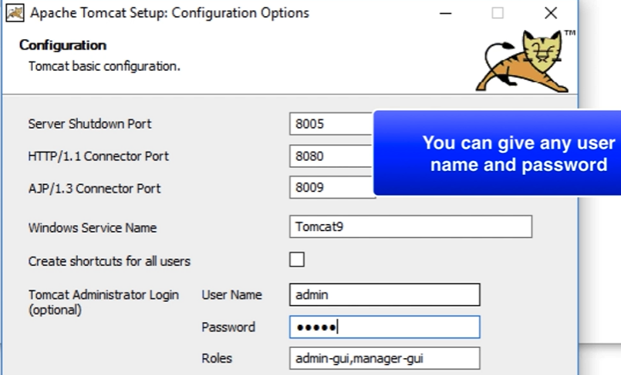

**Default Java location is selected 🡪 select java path which you are using for the project.**

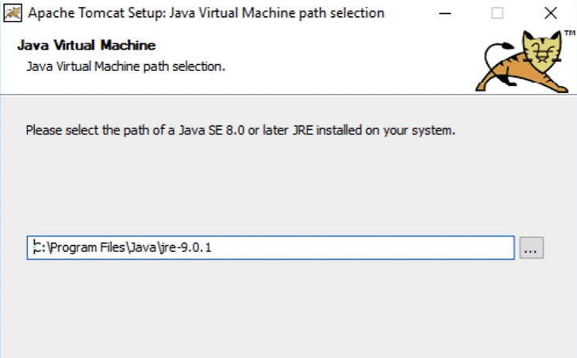

**Click Next 🡪 Next 🡪 Finish**

**Verify the installation -> open browser 🡪 Enter URL 🡪 Click ENTER**

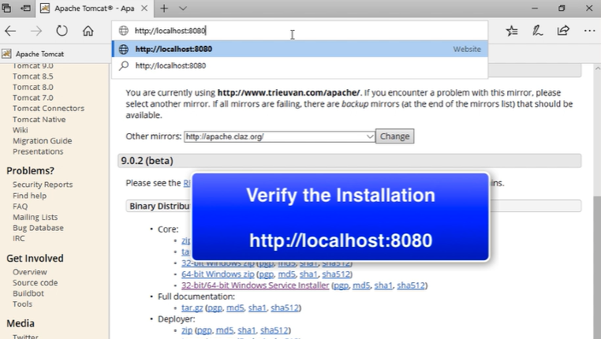

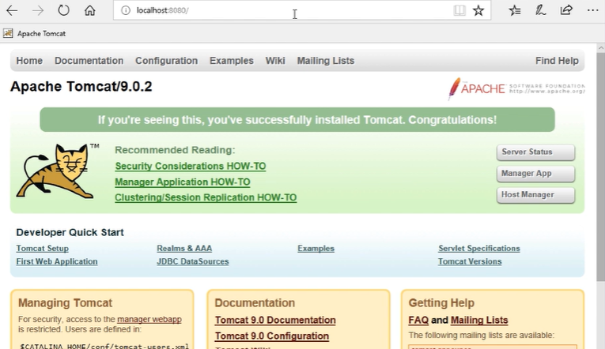

**To Configure:**

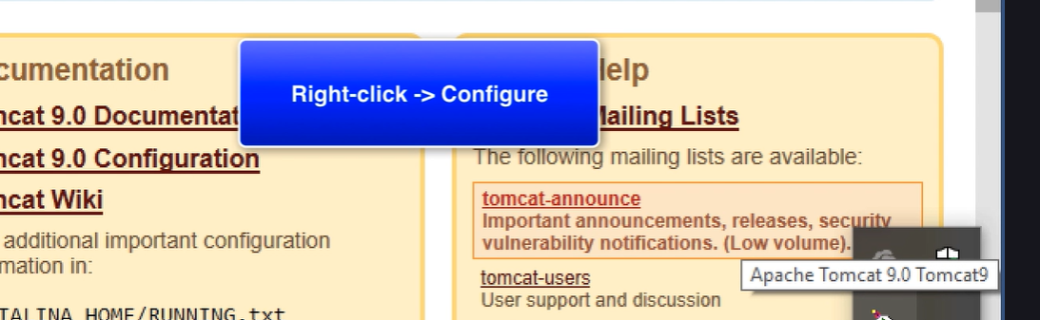

**Check Services:**

**Open Control Panel 🡪 Enter Services.**

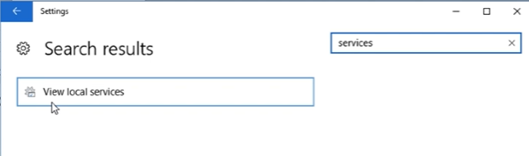

**Start/Stop/Restart the apache server**

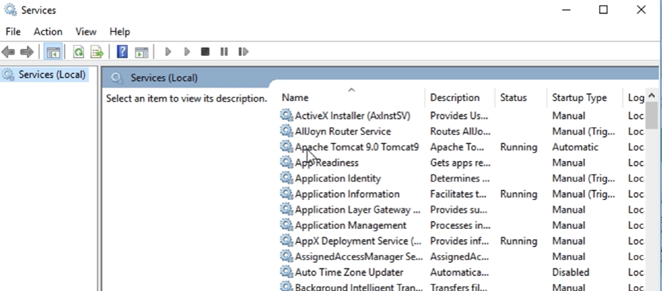

**For now, right click and select Stop 🡪 Stop the service.**

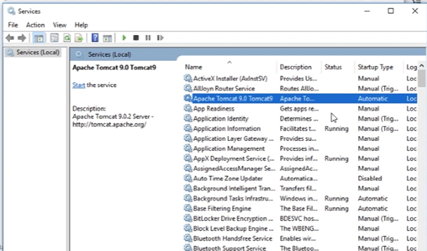

**Eclipse:**

**Make sure Eclipse IDE is 🡪 Java developers and Web Developers.**

**Connecting Eclipse to Tomcat:**

**Open Eclipse 🡪 Select Existing Workspace 🡪 Go to Servers Tab**

**Note:**

**If Server tab is not displaying, Go to Windows menu 🡪 Show View 🡪 Server**

**Step1:**

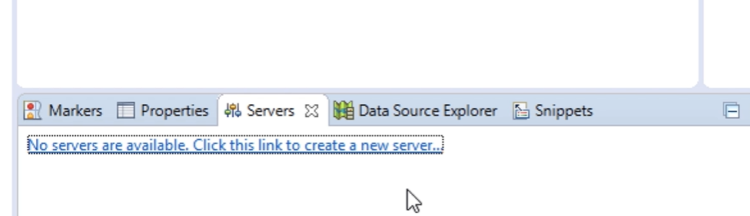

**Step2:**

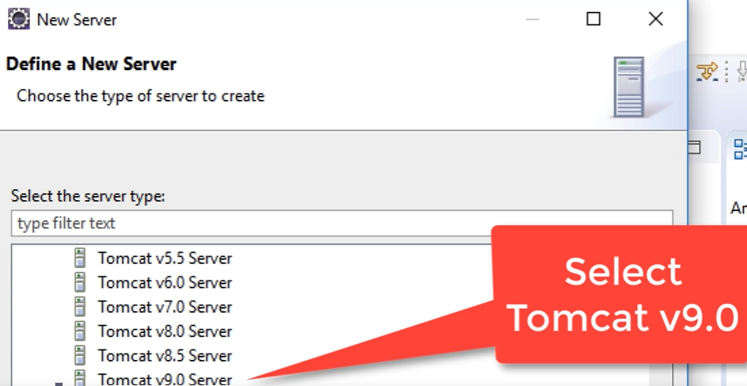

**Step3:**

**Browse and Select Tomcat installation directory**

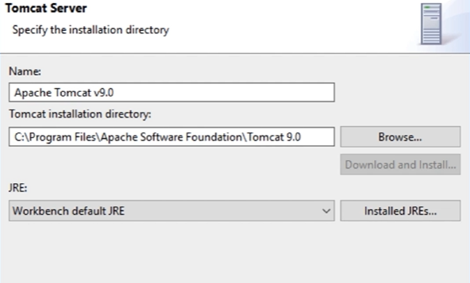

**Step4:**

**Click Next 🡪 Next 🡪 Finish**

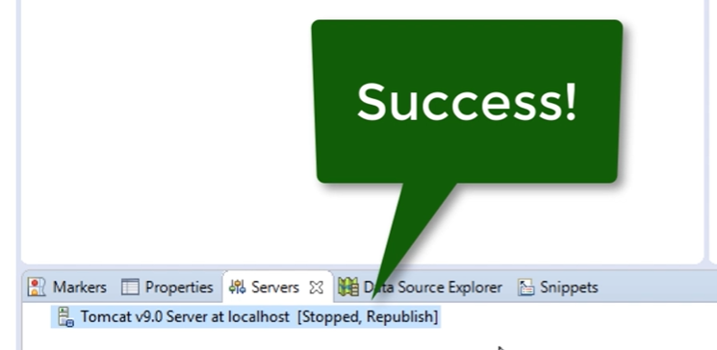

**What is JSP and Servlets:**

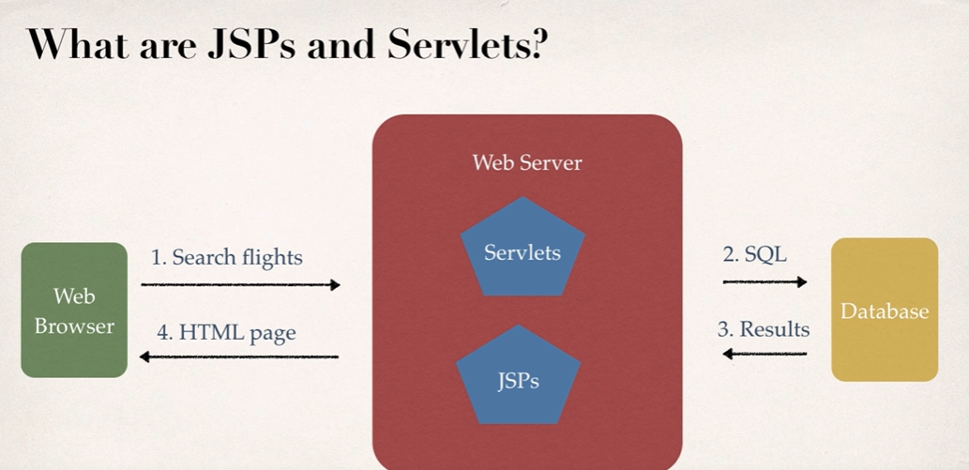

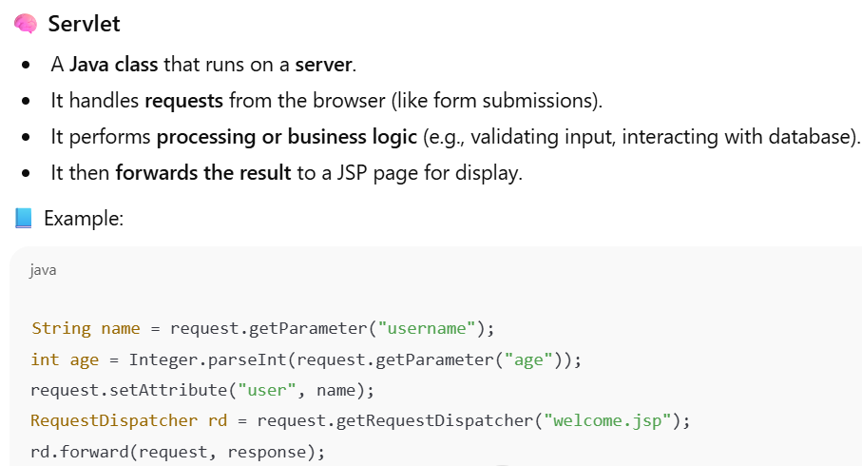

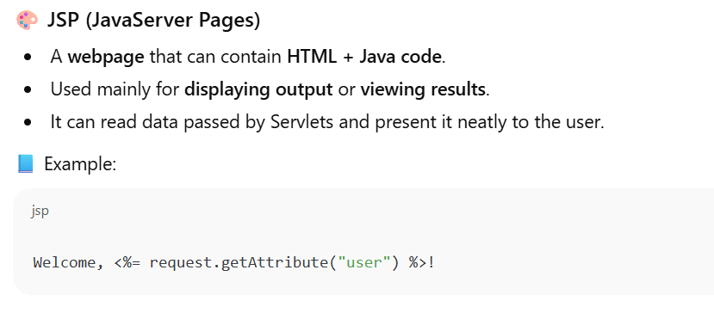

**Diagram:**

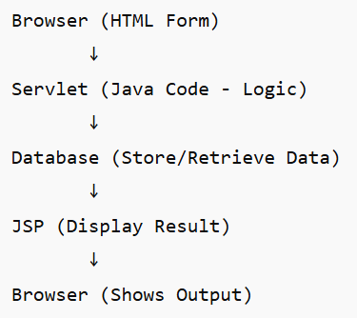

**Flow**:

1. **Browser (Client)**  
   → Sends a request (e.g., submitting an HTML form or clicking a link).  
   Example:

<form action="LoginServlet" method="post">

Username: <input name="user">

Password: <input name="pass">

<input type="submit">

</form>

1. **Servlet (Controller)**  
   → Receives the request using HttpServletRequest.  
   → Processes the logic (validation, DB query, etc.).  
   → Optionally connects to the **Database** via JDBC.  
   → Stores the results (like success message or data).  
   → Forwards the request to a **JSP** for display.
2. **Database (Model)**  
   → Stores or retrieves the required data.  
   Example: SELECT * FROM users WHERE username=?
3. **JSP (View)**  
   → Receives processed data from Servlet.  
   → Displays the response (HTML + dynamic content).  
   Example: “Welcome, Suresh!”
4. **Browser (Client)**  
   → Finally receives the **HTML response** and displays it to the user.

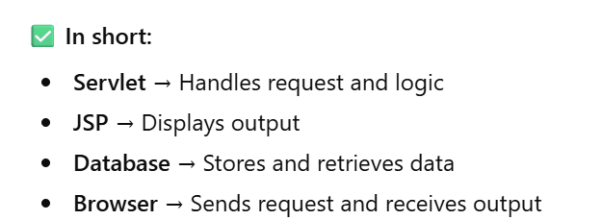

**Eclipse IDE:**

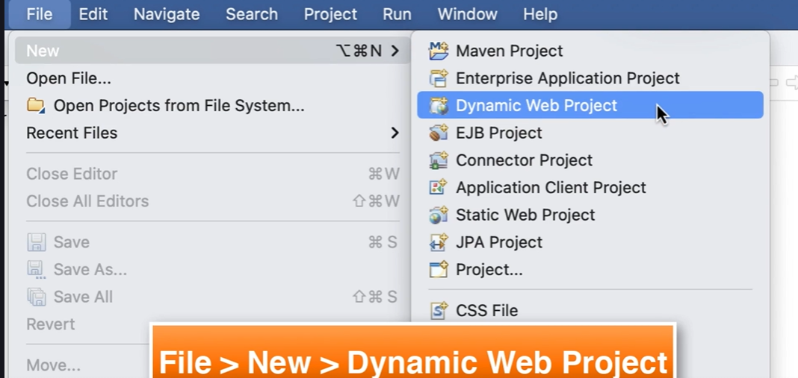

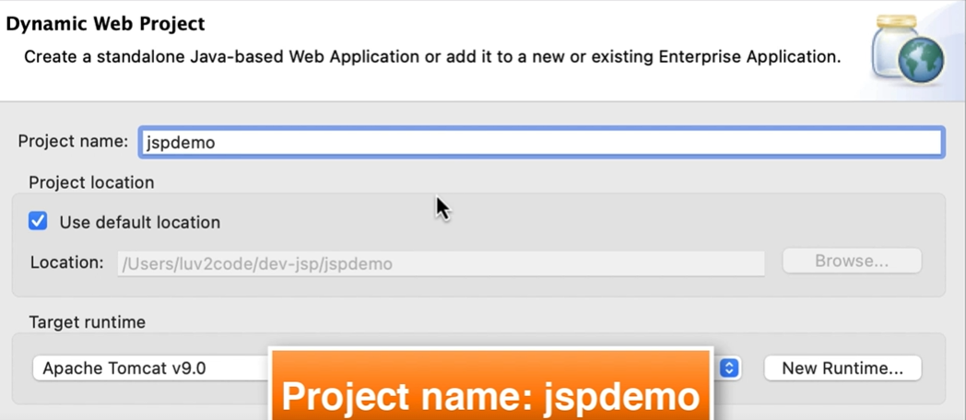

**Select Project Location 🡪 Click on Next**

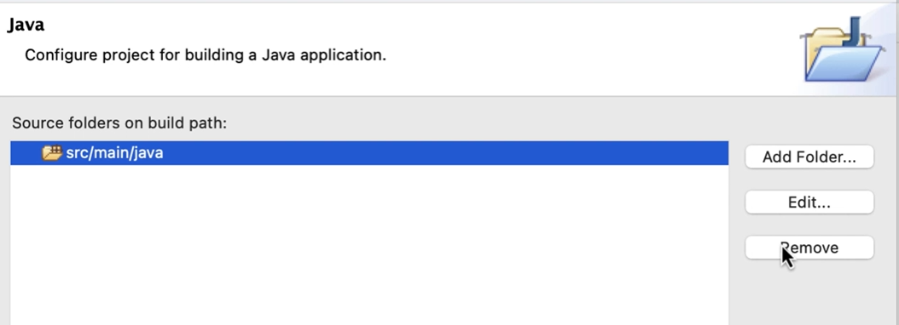

**Remove and add,**

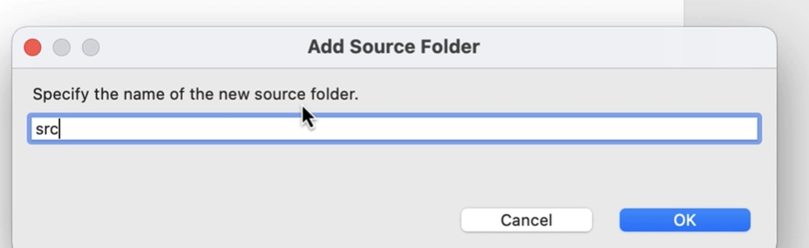

**Click Next and change Content Directory name. select Checkbox for web.xml**

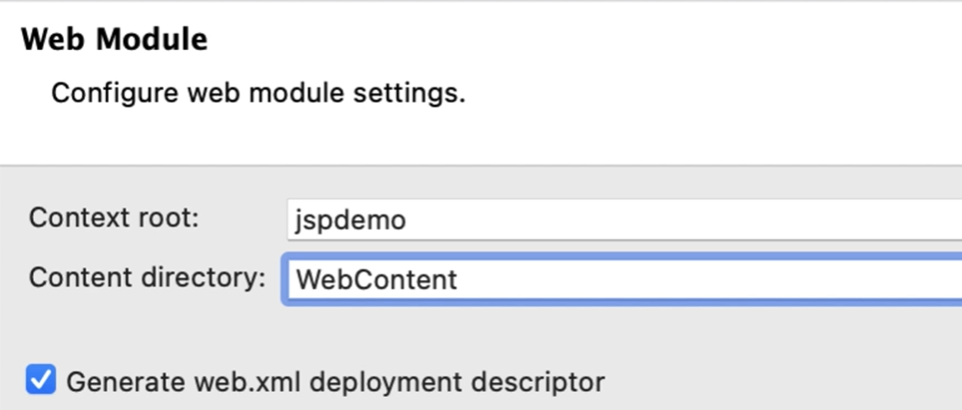

**Click on Finish**

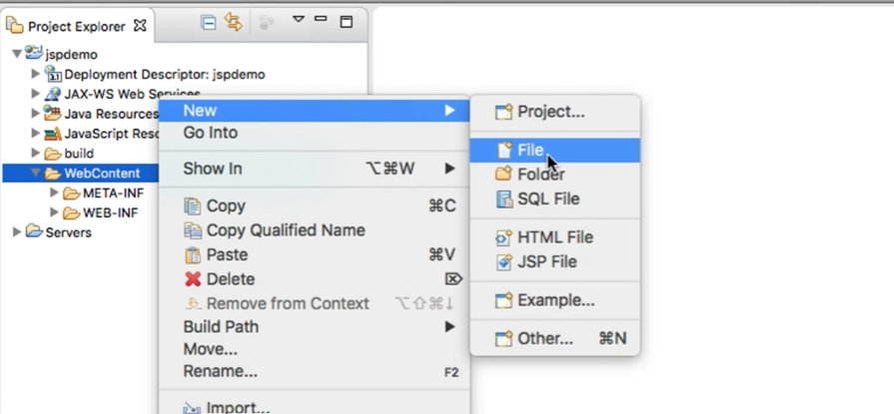

**JSP Hello World**

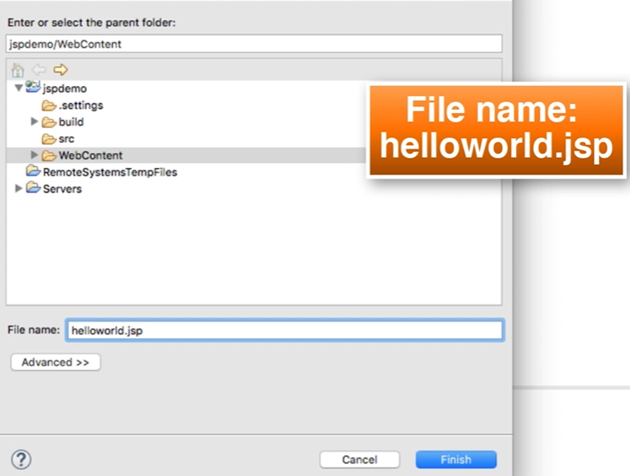

**Click on Finish.**

**Enter the program and click on save:**



**<html>**

**<body>**

**<h3>Hello World of Java!</h3>**

**The time on the server is <%= new java.util.Date() %>**

**</body>**

**</html>**

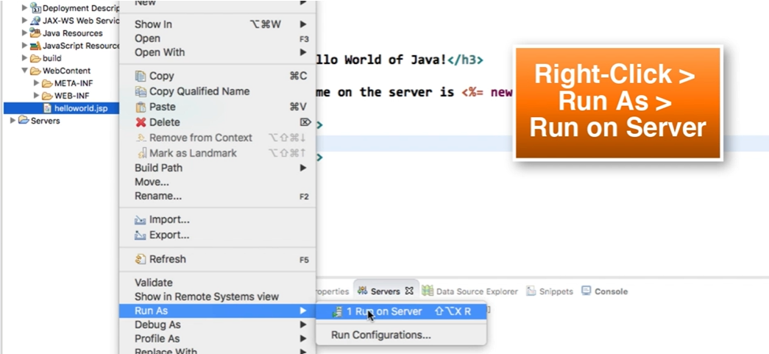

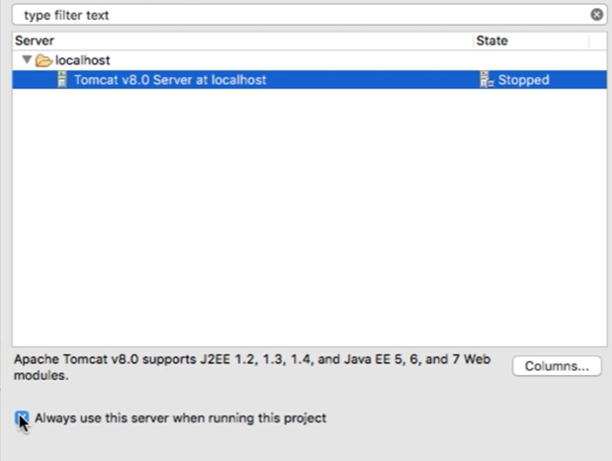

**Click on Finish**

**Note: Change server port and connector port if not working.**

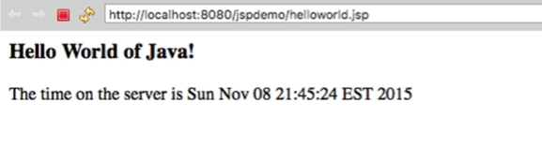

**Copy and Past the URl in any browser.**

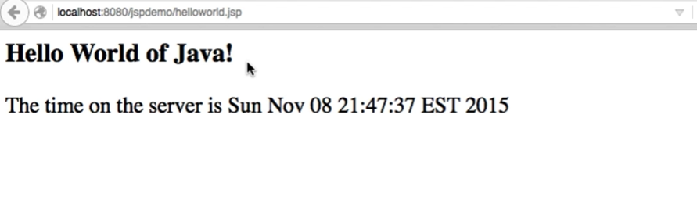

**Now, right + click and do view pagesource 🡪 which takes to the .jsp page**

**JSP Scripting Elements:**

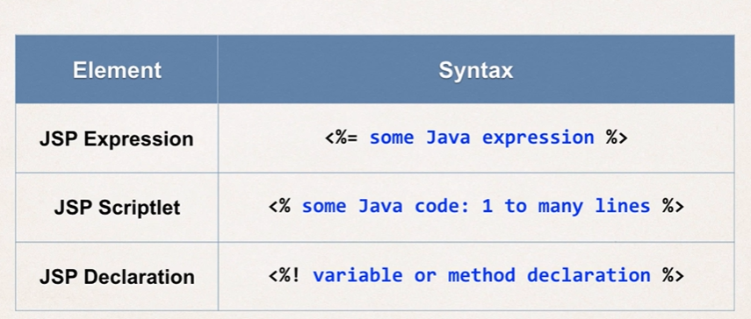

**JSP Expression:**



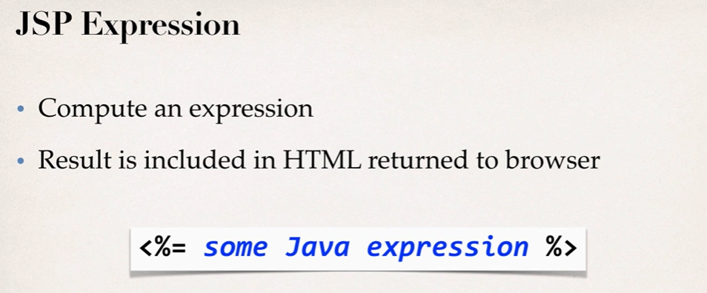

**Example1:**

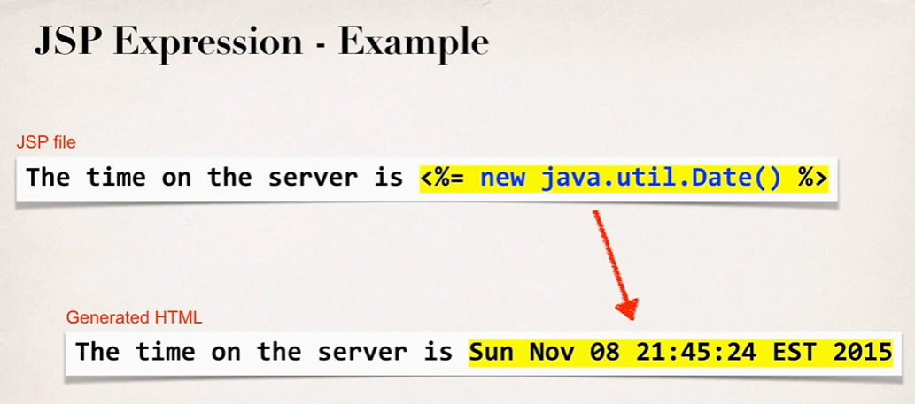

**Example2:**

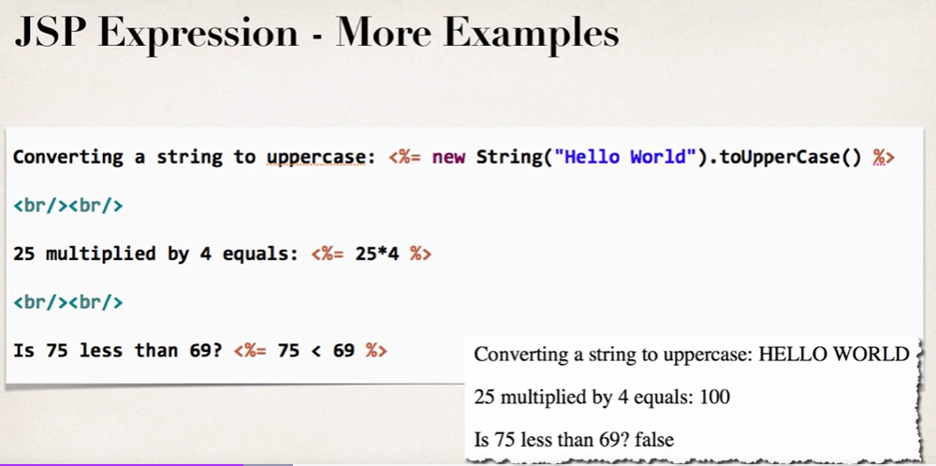

**JSP Scriplet:**



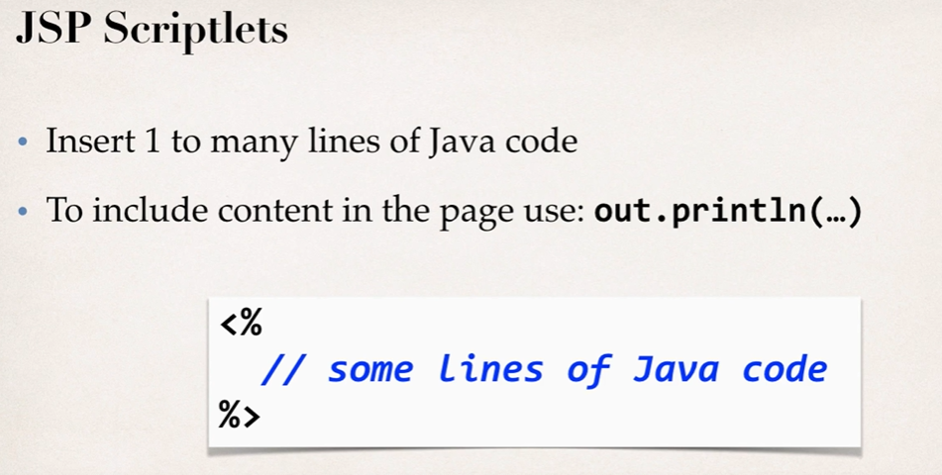

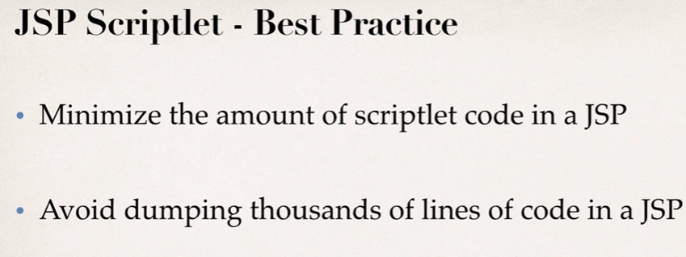

**JSP Declarations:**



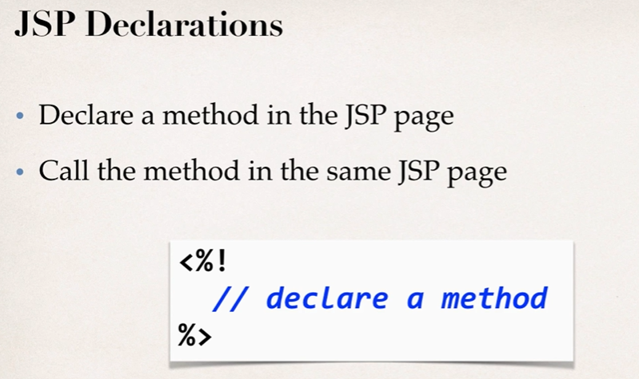

**Calling a Java Class from JSP**

1. Create a Java class
2. Call a java class from JSP.

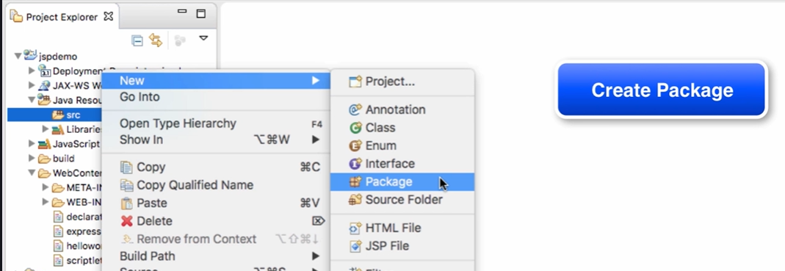

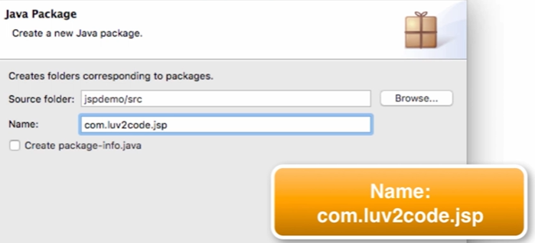

Click on Finish

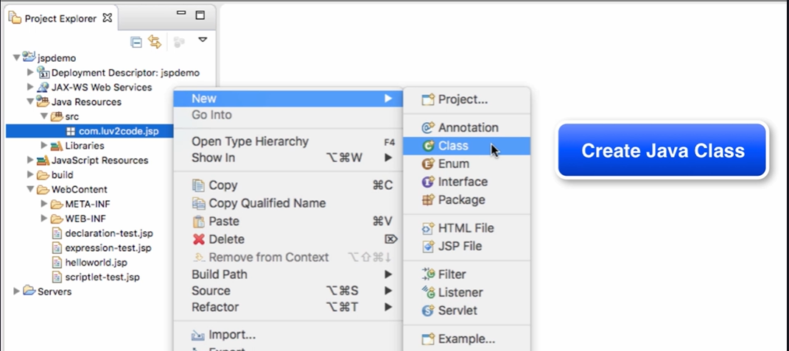

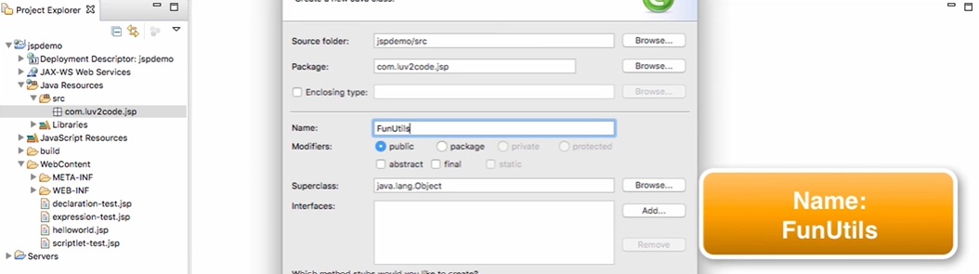

Click on Finish

**Enter the Java Code:**



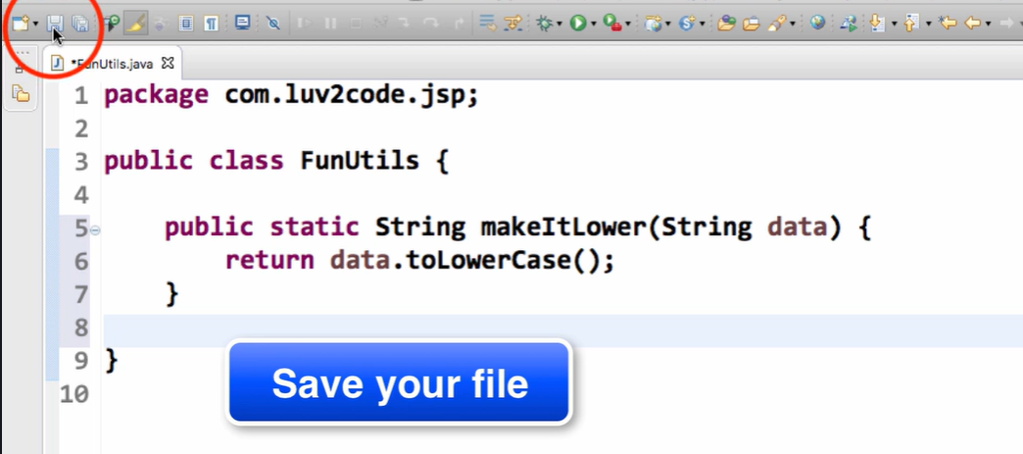

**Now, Create JSP file.**

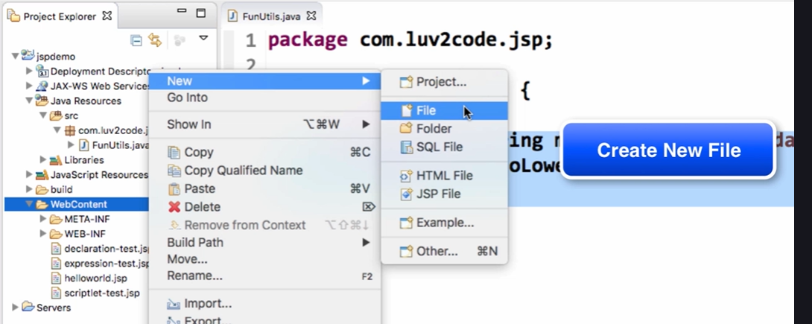

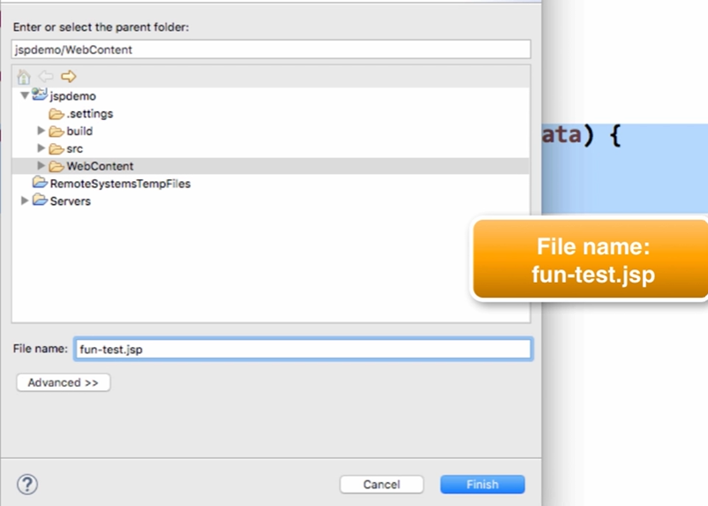

**Click Finish and enter the attached code below in JSP file.**



**Run as 🡪 Run on server**

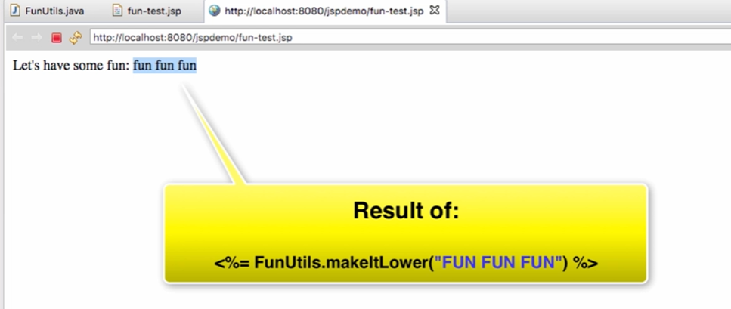

**JSP Built-in Objects:**

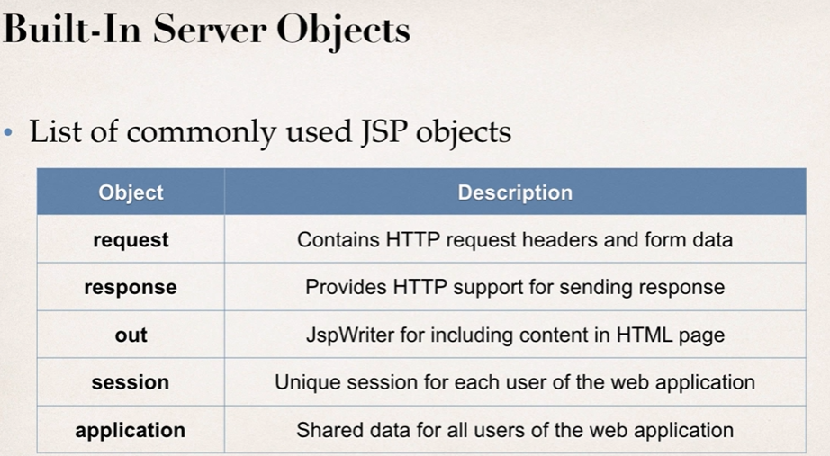

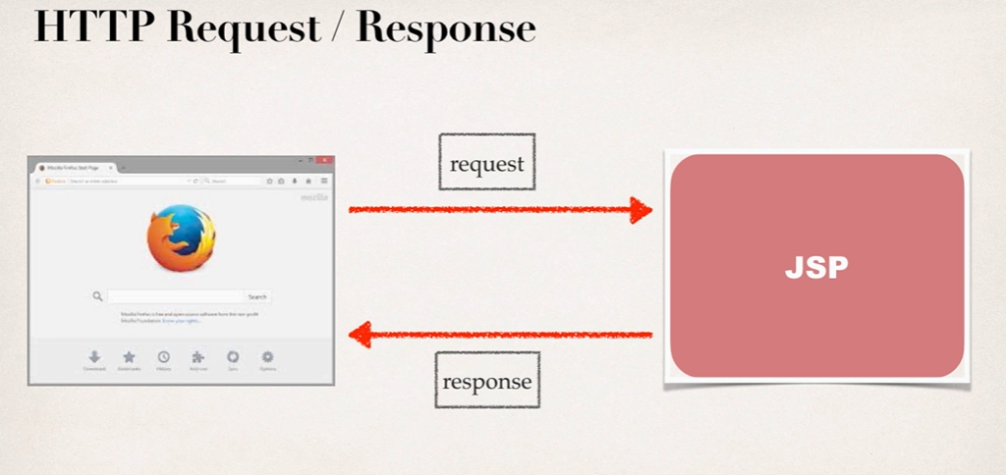

Create JSP file -> Run as 🡪 Run on server



**Output:**

Browser version etc.. with language used.

**Including Files in JSP**



Also Create, my-header.html

<h1 align=”center”>Java Class</h1>

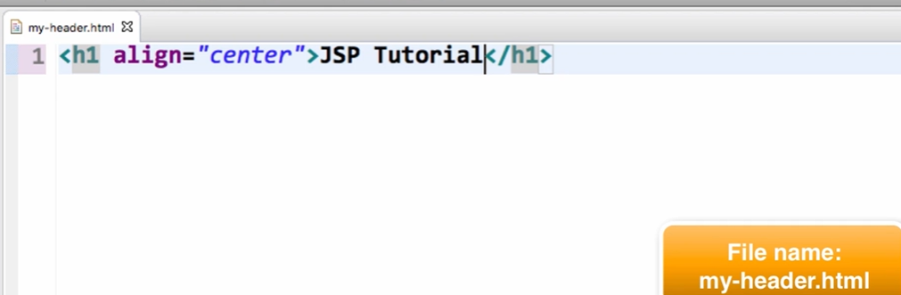

Homepage.jsp 🡪 Run as 🡪 Run on Server

**Reading HTML Form Data with JSP:**

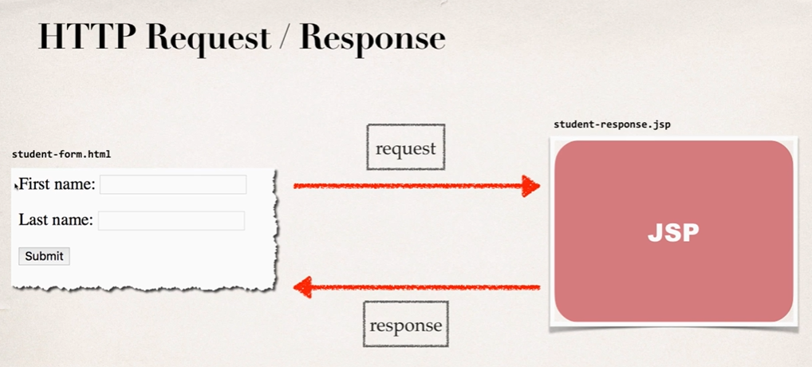

**HTML Form:**

1. Create new file “**student-form.html**”

<html>

<head><title>Student Registration Form</title></head>

<body>

<form action="student-response.jsp">

First name: <input type="text" name="firstName" />

<br/><br/>

Last name: <input type="text" name="lastName" />

<br/><br/>

<input type="submit" value="Submit" />

</form>

</body>

</html>

1. Create new file “**student-form.jsp**”

<html>

<head><title>Student Confirmation Title</title></head>

<body>

The student is confirmed: ${param.firstName} ${param.lastName}

</body>

</html>

1. Execute “**student-form.html**” 🡪 Run as 🡪 Run on server
2. Output: The student is confirmed:<firstname><lastname>

**Drop Down Lists:**

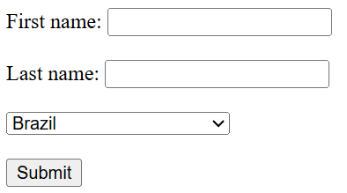

1. Step1: Create new file “**student-dropdown-form.html**”

<html>

<head><title>Student Registration Form</title></head>

<body>

<form action="student-dropdown-response.jsp">

First name: <input type="text" name="firstName" />

<br/><br/>

Last name: <input type="text" name="lastName" />

<br/><br/>

<select name="country">

<option>Brazil</option>

<option>France</option>

<option>Germany</option>

<option>India</option>

<option>Turkey</option>

<option>United Kingdom</option>

<option>United States of America</option>

</select>

<br/><br/>

<input type="submit" value="Submit" />

</form>

</body>

</html>

1. Step2: Create new file “**student-dropdown-response.jsp**”



1. Execute “**student-dropdown-form.html**” 🡪 Run as 🡪 Run on server
2. Output:

**Radiobutton:**

1. Step1: Create new file “**student-radio-form.html**”

<html>

<head><title>Student Registration Form</title></head>

<body>

<form action="student-radio-response.jsp">

First name: <input type="text" name="firstName" />

<br/><br/>

Last name: <input type="text" name="lastName" />

<br/><br/>

<input type=" radio" name="favoriteLanguage" value="Java"> Java

<input type=" radio" name="favoriteLanguage" value="C#"> C#

<input type=" radio" name="favoriteLanguage" value="PHP"> PHP

<input type=" radio" name="favoriteLanguage" value="Ruby"> Ruby

<br/><br/>

<input type="submit" value="Submit" />

</form>

</body>

</html>

1. Step2: Create new file “**student-radio-response.jsp**”



1. Execute “**student-radio.html**” 🡪 Run as 🡪 Run on server
2. Output:

**Checkbox:**

1. Step1: Create new file “**student-checkbox-form.html**”

<html>

<head><title>Student Registration Form</title></head>

<body>

<form action="student-checkbox-response.jsp">

First name: <input type="text" name="firstName" />

<br/><br/>

Last name: <input type="text" name="lastName" />

<br/><br/>

<input type="checkbox" name="favoriteLanguage" value="Java"> Java

<input type="checkbox" name="favoriteLanguage" value="C#"> C#

<input type="checkbox" name="favoriteLanguage" value="PHP"> PHP

<input type="checkbox" name="favoriteLanguage" value="Ruby"> Ruby

<br/><br/>

<input type="submit" value="Submit" />

</form>

</body>

</html>

1. Step2: Create new file “**student-checkbox-response.jsp**”



1. Execute “**student-checkbox-form.html**” 🡪 Run as 🡪 Run on server
2. Output:

**JSP Standard Tag Library(JSTL):**

It’s a collection of **ready-made tags** (like <c:forEach>, <c:if>, etc.) that make it easier to write JSP pages **without using Java code (scriptlets)** inside HTML.

**Why JSTL is Used**

* To **avoid Java code inside JSP** (cleaner pages)
* To **simplify common tasks** like:
  + looping
  + conditional checks
  + formatting

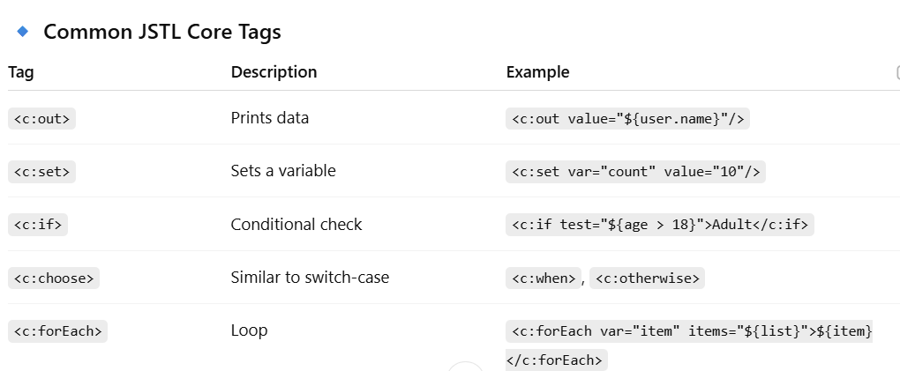

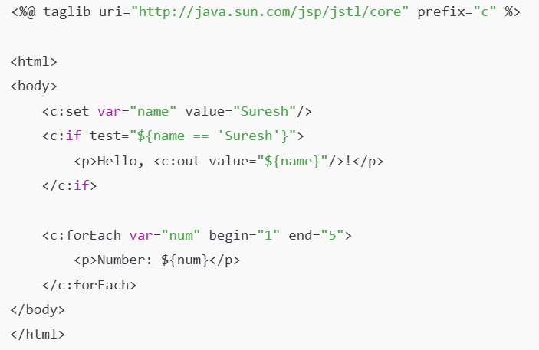

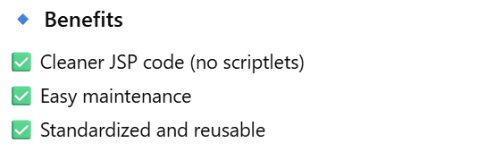

**Install JSTL Jars:**

Create new dynamic project

Project Name: tagdemo

Source folder “src”(remove 🡪 src/java/main)

Content Directory: WebContent

Click Finish

**How to add jars?**

Go to WenContent Folder 🡪 WED-INF (Copy the below jars and paste it)



Create new file in WebContent 🡪 “test.jsp”

<%@ taglib uri="http://java.sun.com/jsp/jstl/core" prefix="c" %>

<html>

<body>

<c:set var="stuff" value="<%= new java.util.Date() %>" />

Time on the server is ${stuff}

</body>

</html>

**Core Tags:**

Core tags handle **basic flow control, variable management, and iteration** — things similar to what you do with Java logic.

**Common Tasks:**

* Setting or getting variables
* Conditional checks
* Loops
* URL and parameter handling

**Programs**

**Looping with forEach:**

Create new file in Webcontent : “**foreach-simple-test.jsp**”

<%@ taglib uri="http://java.sun.com/jsp/jstl/core" prefix="c" %>

<%

String[] cities = {"Mumbai", "Singapore", "Philadelphia"};

pageContext.setAttribute("myCities", cities);

%>

<html>

<body>

<c:forEach var="tempCity" items="${myCities}">

${tempCity} <br/>

</c:forEach>

</body>

</html>

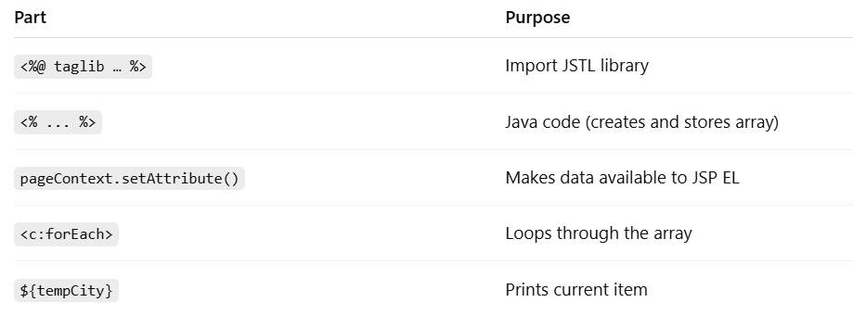

**Looping with HTML Table:**

1. Step1: Create new package in src(or use existing) new file “**student.java**”

package com.demo.jsp.tagdemo;

public class Student {

private String firstName;

private String lastName;

private boolean goldCustomer;

public Student(String firstName, String lastName, boolean goldCustomer) {

super();

this.firstName = firstName;

this.lastName = lastName;

this.goldCustomer = goldCustomer;

}

public String getFirstName() {

return firstName;

}

public void setFirstName(String firstName) {

this.firstName = firstName;

}

public String getLastName() {

return lastName;

}

public void setLastName(String lastName) {

this.lastName = lastName;

}

public boolean isGoldCustomer() {

return goldCustomer;

}

public void setGoldCustomer(boolean goldCustomer) {

this.goldCustomer = goldCustomer;

}

}

1. Step2: Create new file “**foreach-student-test.jsp**”

<%@ taglib uri="http://java.sun.com/jsp/jstl/core" prefix="c" %>

<%@ page import="java.util.*,com.demo.jsp.tagdemo.Student" %>

<%

List<Student> data = new ArrayList<>();

data.add(new Student("John", "Doe", false));

data.add(new Student("Maxwell", "Johnson", false));

data.add(new Student("Mary", "Public", true));

pageContext.setAttribute("myStudents", data);

%>

<html>

<body>

<table border="1">

<tr>

<th>First Name</th>

<th>Last Name</th>

<th>Gold Customer</th>

</tr>

<c:forEach var="tempStudent" items="${myStudents}">

<tr>

<td>${tempStudent.firstName}</td>

<td>${tempStudent.lastName}</td>

<td>${tempStudent.goldCustomer}</td>

</tr>

</c:forEach>

</table>

</body>

</html>

1. Execute “**foreach-student-test.jsp**” 🡪 Run as 🡪 Run on server
2. Output:

**IF tag:**

Used for **simple, single-condition checks** (like a basic if statement in Java).

Create new file “**if-student-test.jsp**”

<%@ taglib uri="http://java.sun.com/jsp/jstl/core" prefix="c" %>

<%@ page import="java.util.*,com.demo.jsp.tagdemo.Student" %>

<%

List<Student> data = new ArrayList<>();

data.add(new Student("John", "Doe", false));

data.add(new Student("Maxwell", "Johnson", false));

data.add(new Student("Mary", "Public", true));

pageContext.setAttribute("myStudents", data);

%>

<html>

<body>

<table border="1">

<tr>

<th>First Name</th>

<th>Last Name</th>

<th>Gold Customer</th>

</tr>

<c:forEach var="tempStudent" items="${myStudents}">

<tr>

<td>${tempStudent.firstName}</td>

<td>${tempStudent.lastName}</td>

<td>

//Display Special Discount is student is Gold Customer

<c:if test="${tempStudent.goldCustomer}">

Special Discount

</c:if>

<c:if test="${not tempStudent.goldCustomer}">

No Special Dicount

</c:if>

</td>

</tr>

</c:forEach>

</table>

</body>

</html>

**Choose**

like a Java if–else if–else chain or a switch statement.

Create new file “**choose-student-test.jsp**”

<%@ taglib uri="http://java.sun.com/jsp/jstl/core" prefix="c" %>

<%@ page import="java.util.*,com.demo.jsp.tagdemo.Student" %>

<%

List<Student> data = new ArrayList<>();

data.add(new Student("John", "Doe", false));

data.add(new Student("Maxwell", "Johnson", false));

data.add(new Student("Mary", "Public", true));

pageContext.setAttribute("myStudents", data);

%>

<html>

<body>

<table border="1">

<tr>

<th>First Name</th>

<th>Last Name</th>

<th>Gold Customer</th>

</tr>

<c:forEach var="tempStudent" items="${myStudents}">

<tr>

<td>${tempStudent.firstName}</td>

<td>${tempStudent.lastName}</td>

<td>

<c:choose>

<c:when test="${tempStudent.goldCustomer}">

Special Discount

</c:when>

<c:otherwise>

no soup for you!

</c:otherwise>

</c:choose>

</td>

</tr>

</c:forEach>

</table>

</body>

</html>

**Function Tags**

Function tags provide **helper functions for working with strings and collections**, similar to built-in Java methods like String.contains() or String.length().

**JSTL Function Tags - length, toUpperCase and startsWith:**

Create new file “**function-test.jsp**”

<%@ taglib uri="http://java.sun.com/jsp/jstl/core" prefix="c" %>

<%@ taglib uri="http://java.sun.com/jsp/jstl/functions" prefix="fn" %>

<html>

<body>

<c:set var="data" value="democode" />

Length of the string <b>${data}</b>: ${fn:length(data)}

<br/><br/>

Uppercase version of the string <b>${data}</b>: ${fn:toUpperCase(data)}

<br/><br/>

Does the string <b>${data}</b> start with <b>demo</b>?: ${fn:startsWith(data, "dem")}

</body>

</html>

**Output:**

Length of the string democode: 8

Uppercase version of the string democode: DEMOCODE

Does the string democode start with demo?: true

**JSTL Function Tags - split and join:**

Create new file “**split-join-test.jsp**”

<%@ taglib uri="http://java.sun.com/jsp/jstl/core" prefix="c" %>

<%@ taglib uri="http://java.sun.com/jsp/jstl/functions" prefix="fn" %>

<html>

<body>

<c:set var="data" value="Singapore,Toyko,Mumbai,London" />

<h3>Split Demo</h3>

<c:set var="citiesArray" value="${fn:split(data, ',')}" />

<c:forEach var="tempCity" items="${citiesArray}" >

${tempCity} <br/>

</c:forEach>

<h3>Join Demo</h3>

<c:set var="fun" value="${fn:join(citiesArray, '*')}" />

Result of joining: ${fun}

</body>

</html>

**Output:**

Split Demo

Singapore

Toyko

Mumbai

London

Join Demo

Result of joining: Singapore*Toyko*Mumbai*London

* **Core tags** = “do something” (logic, looping, printing)
* **Function tags** = “calculate something” (return a value)

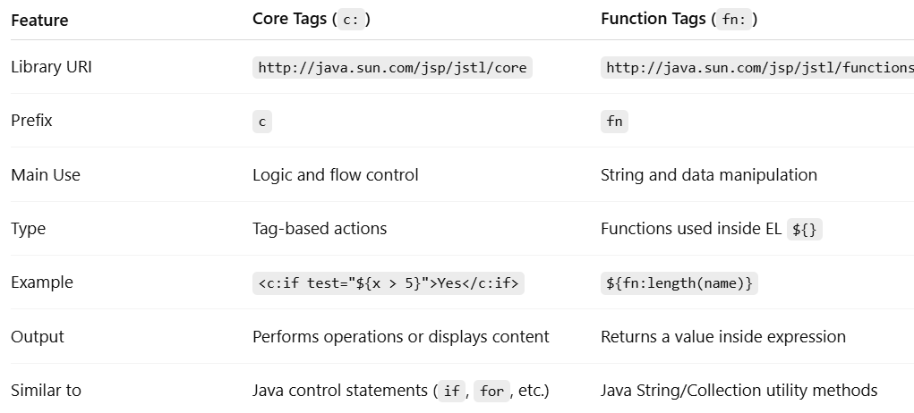

**Servlets:**

A **Servlet** is basically a **Java class** that handles **HTTP requests and responses**.

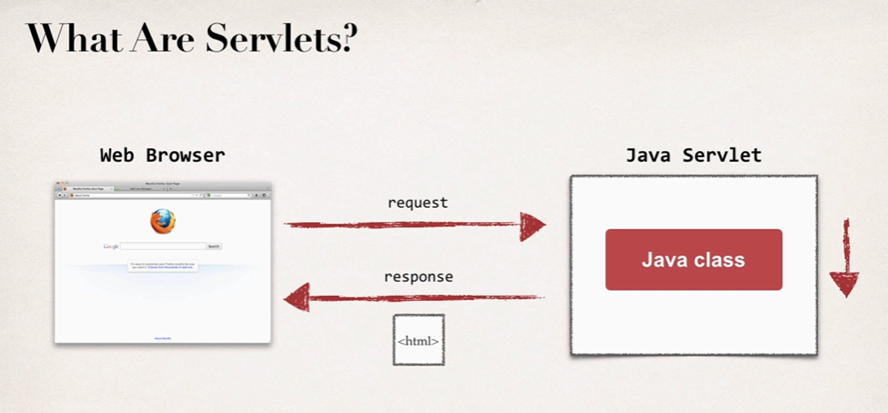

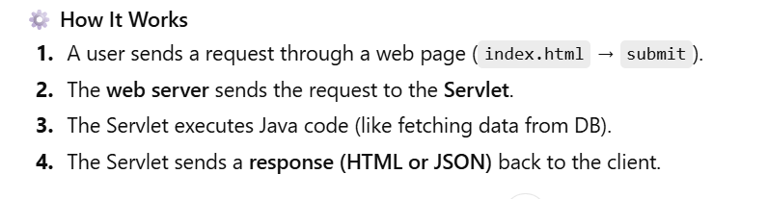

**Servlet vs Jsp:**

**Servlet: does the Business Logic**

**JSP: handles the Presentation view**

**MVC, Model View Controller – Design Pattern**

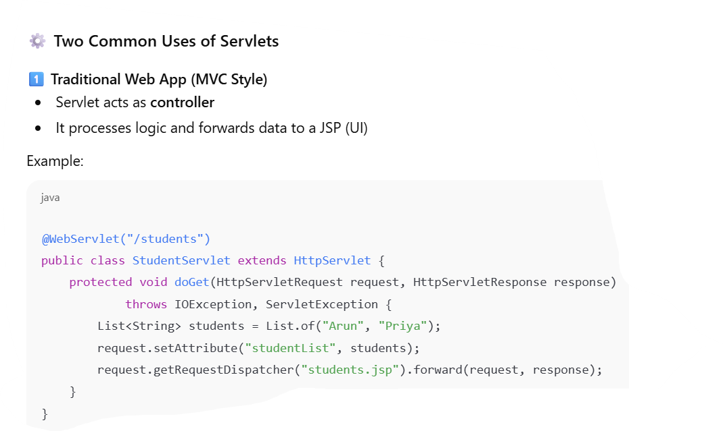

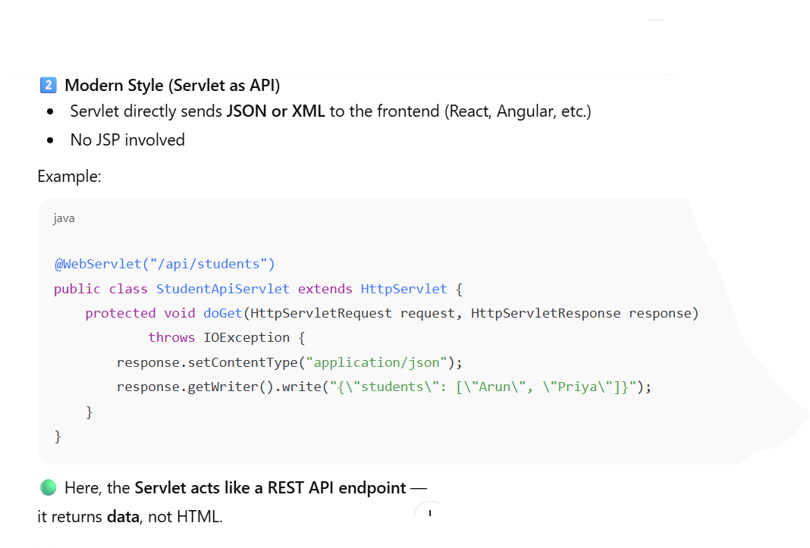

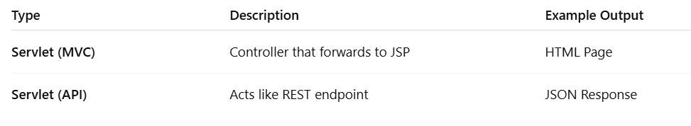

**Project:**

Create new dynamic project

Project Name: servletdemo

Source folder “src”(remove 🡪 src/java/main)

Content Directory: WebContent

Click Finish

**Create Package:**

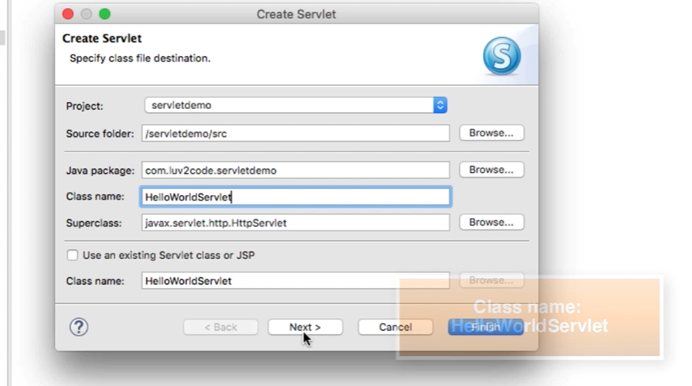

**Click Next 🡪 Click Next**

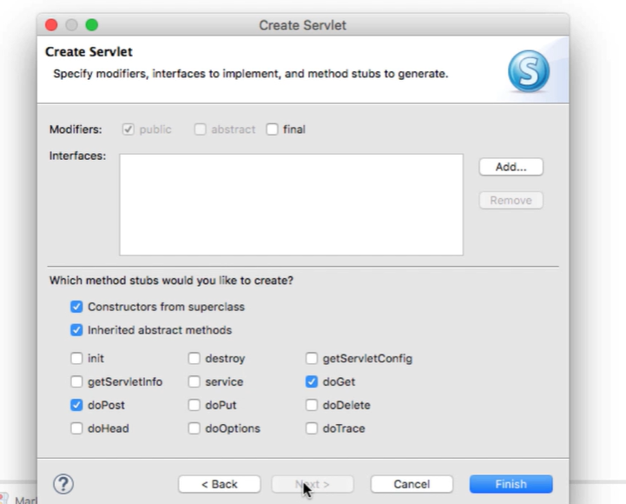

**Click Finish.**

**Go to src 🡪 package 🡪 java file**



Execute the program 🡪 Run on server.

**Reading HTML Form Data with Servlets:**

Img1 and 2

Program:

1. Create Html form
   1. WebContent -> new File 🡪 “student-form.html”

<html>

<body>

<form action="StudentServlet" method="GET">

First name: <input type="text" name="firstName" />

<br/><br/>

Last name: <input type="text" name="lastName" />

<br/><br/>

<input type="submit" value="Submit" />

</form>

</body>

</html>

1. Create Servlet
   1. Go to src 🡪 Create file “StudentServlet.java”
   2. Write code



* 1. Request : contains the form data from html
  2. getParameter: read Form data

1. student-form.html 🡪 Run on server

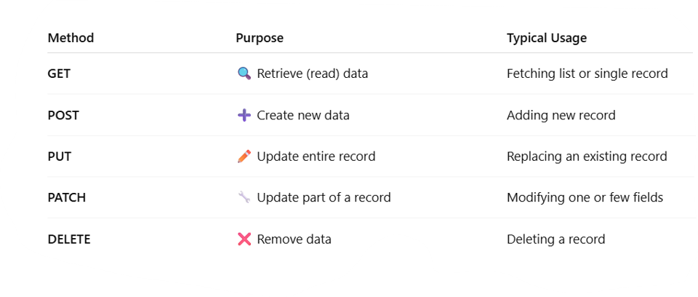

**Reading Servlets Parameters:**

Web app can make use of configuration parameters

It is located in WEB-IF/web.xml

Program:

1. Go to Webcontent 🡪 WEB-IF/web.xml

<?xml version="1.0" encoding="UTF-8"?>

<web-app xmlns:xsi="http://www.w3.org/2001/XMLSchema-instance" xmlns="http://xmlns.jcp.org/xml/ns/javaee" xsi:schemaLocation="http://xmlns.jcp.org/xml/ns/javaee http://xmlns.jcp.org/xml/ns/javaee/web-app_3_1.xsd" id="WebApp_ID" version="3.1">

<display-name>servletdemo</display-name>

<context-param>

<param-name>max-shopping-cart-size</param-name>

<param-value>99</param-value>

</context-param>

<context-param>

<param-name>project-team-name</param-name>

<param-value>The Coding Gurus</param-value>

</context-param>

<welcome-file-list>

<welcome-file>index.html</welcome-file>

<welcome-file>index.htm</welcome-file>

<welcome-file>index.jsp</welcome-file>

<welcome-file>default.html</welcome-file>

<welcome-file>default.htm</welcome-file>

<welcome-file>default.jsp</welcome-file>

</welcome-file-list>

</web-app>

1. Create Servlet
   1. Go to src 🡪 Create file “TestParamServlet.java”
   2. Write code



* 1. getServletContext() 🡪 class to read/parse web.xml

1. TestParamServlet.java 🡪 Run on server

**MVC**

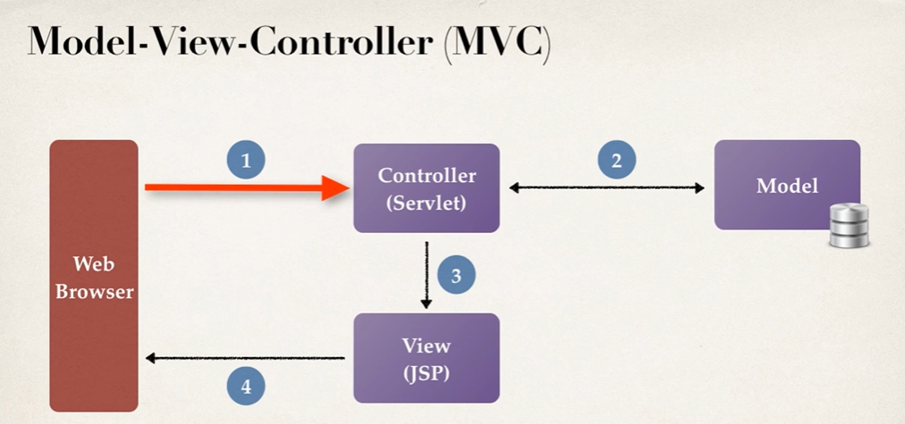

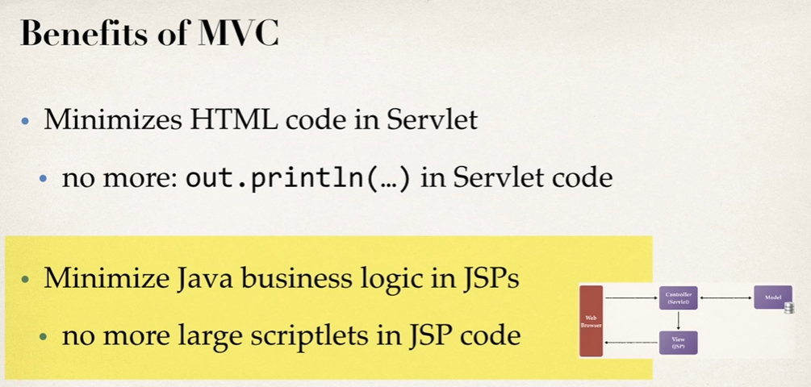

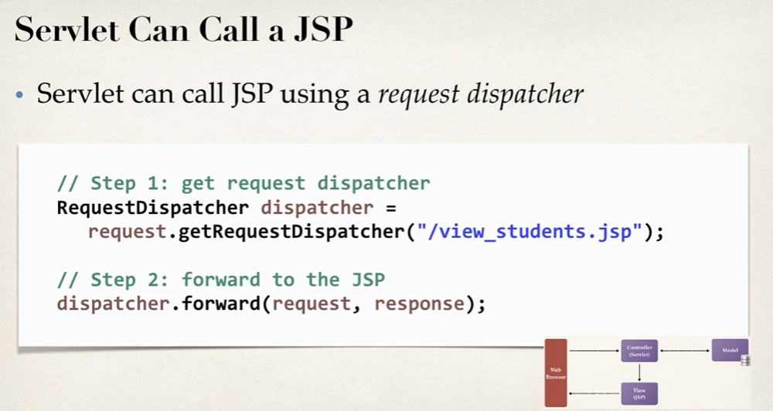

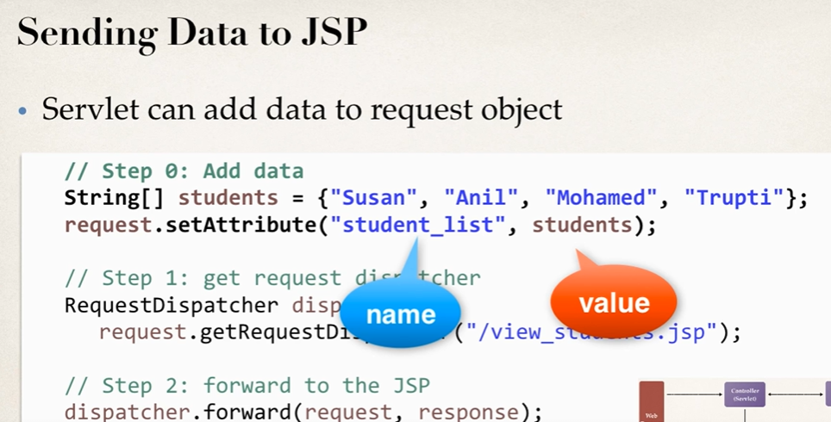

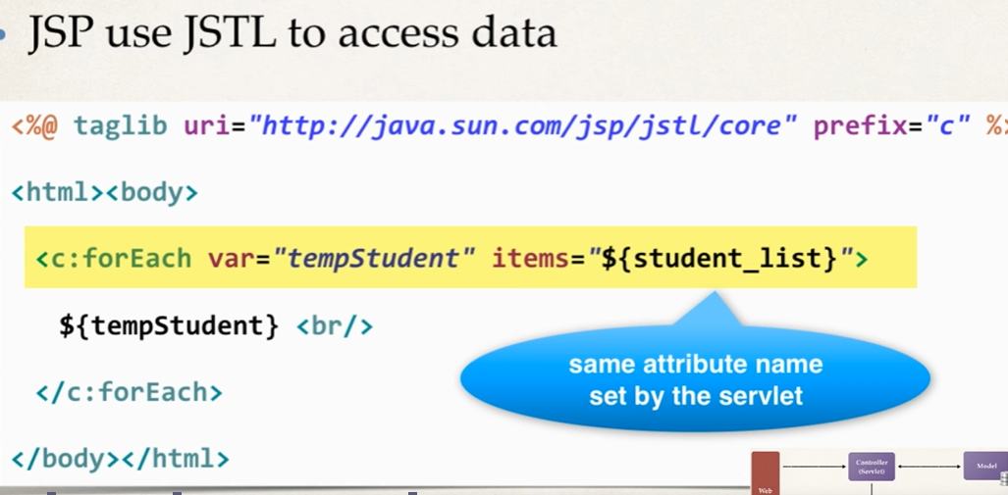

**Pre-requisites:**

* **Use Servlet Demo project (**Create new dynamic project, Project Name: servletdemo,Source folder “src”(remove 🡪 src/java/main),Content Directory: WebContent,Click Finish)
* **Add jstl jars in WebContent** 🡪 **Lib**

**Program 1: Using List**

1. Java Resources 🡪 From package 🡪 New 🡪 Create Servlet
   1. Go to src 🡪 Create file “MvcDemoServlet”
2. Write code



1. Go to Webcontent 🡪 New File 🡪 view_students.jsp

<%@ taglib uri="http://java.sun.com/jsp/jstl/core" prefix="c" %>

<html>

<body>

<c:forEach var="tempStudent" items="${student_list}">

${tempStudent} <br/>

</c:forEach>

</body>

</html>

1. MvcDemoServlet.java 🡪 Run on server

**Program 2: Using HTML Table**



**1 🡪** MvcDemoServletTwo.java

**2 🡪** view_students_two.jsp

3 🡪 StudentsDataUtil.java

Pre-requisites:

* Project: servletdemo (Use Existing project)
* Go to 🡪 Java Resources 🡪 src 🡪 new package : mvctwo

Part 1:

* Create Student Class
* Go to 🡪 Java Resources 🡪 src 🡪 package : mvctwo 🡪 New Class : Student

package com.demo.servletdemo.mvctwo;

public class Student {

private String firstName;

private String lastName;

private String email;

//right click 🡪 source 🡪 Generate constructors using Fields

public Student(String firstName, String lastName, String email) {

super();

this.firstName = firstName;

this.lastName = lastName;

this.email = email;

}

//right click 🡪 source 🡪 Generate Getters and Setters

public String getFirstName() {

return firstName;

}

public void setFirstName(String firstName) {

this.firstName = firstName;

}

public String getLastName() {

return lastName;

}

public void setLastName(String lastName) {

this.lastName = lastName;

}

public String getEmail() {

return email;

}

public void setEmail(String email) {

this.email = email;

} }

Part 2: //This is called by the servlet (Acts as a **data source** for the servlet)

* Create StudentsDataUtil
* Go to 🡪 Java Resources 🡪 src 🡪 package : mvctwo 🡪 New Class : StudentsDataUtil

package com.demo.servletdemo.mvctwo;

import java.util.ArrayList;

import java.util.List;

public class StudentDataUtil {

public static List<Student> getStudents() {

// create an empty list

List<Student> students = new ArrayList<>();

// add sample data

students.add(new Student("nishi ", "stud1", "nishi@gmail.com"));

students.add(new Student("aastha ", " stud2", "aastha@gmail.com"));

students.add(new Student("rani", " stud3", "rani@ gmail.com"));

students.add(new Student("pratham ", " stud4","pratham@gmail.com"));

// return the list

return students;

} }

Part 3: //This is called by the servlet (Acts as a **bridge** between data (model) and the JSP (view))

* Create MVC Servlet
* Go to 🡪 Java Resources 🡪 src 🡪 package : mvctwo 🡪 New Servlet : MvcDemoServletTwo

package com.demo.servletdemo.mvctwo;

import java.io.IOException;

import java.util.List;

import javax.servlet.RequestDispatcher;

import javax.servlet.ServletException;

import javax.servlet.annotation.WebServlet;

import javax.servlet.http.HttpServlet;

import javax.servlet.http.HttpServletRequest;

import javax.servlet.http.HttpServletResponse;

/**

* Servlet implementation class MvcDemoServletTwo

*/

@WebServlet("/MvcDemoServletTwo")

public class MvcDemoServletTwo extends HttpServlet {

private static final long serialVersionUID = 1L;

/**

* @see HttpServlet#HttpServlet()

*/

public MvcDemoServletTwo() {

super();

// TODO Auto-generated constructor stub

}

/**

* @see HttpServlet#doGet(HttpServletRequest request, HttpServletResponse response)

*/

protected void doGet(HttpServletRequest request, HttpServletResponse response) throws ServletException, IOException {

// step 1: get the student data from helper class (model)

List<Student> students = StudentDataUtil.getStudents();

// step 2: add students to request object

request.setAttribute("student_list", students);

// step 3: get request dispatcher

RequestDispatcher dispatcher =

request.getRequestDispatcher("view_students_two.jsp");

// step 4: now forward to JSP

dispatcher.forward(request, response);

}

/**

* @see HttpServlet#doPost(HttpServletRequest request, HttpServletResponse response)

*/

protected void doPost(HttpServletRequest request, HttpServletResponse response) throws ServletException, IOException {

// TODO Auto-generated method stub

doGet(request, response);

} }

Part 4: Shows the list of students from the request attribute student_list

* Create JSP View with HTML Tables

Go to 🡪 WebContent🡪 New Class : view_students_two.jsp

<%@ taglib uri="http://java.sun.com/jsp/jstl/core" prefix="c" %>

<html>

<body>

<h2>Student Table Demo</h2>

<hr>

<br/>

<table border="1">

<tr>

<th>First Name</th>

<th>Last Name</th>

<th>Email Name</th>

</tr>

<c:forEach var="tempStudent" items="${student_list}">

<tr>

<td>${tempStudent.firstName}</td>

<td>${tempStudent.lastName}</td>

<td>${tempStudent.email}</td>

</tr>

</c:forEach>

</table>

</body>

</html>

Part 5: Execute the program

* MvcDemoServletTwo.java 🡪 Run on server

(Or)

Part 6: Create index.html file

Go to 🡪 WebContent🡪 New File : index.hml

<html>

<body>

<a href="MvcDemoServletTwo">View Students with MVC Two</a>

</body>

</html>

* index.hml 🡪 Run on server
* Click on link to trigger MvcDemoServletTwo file.

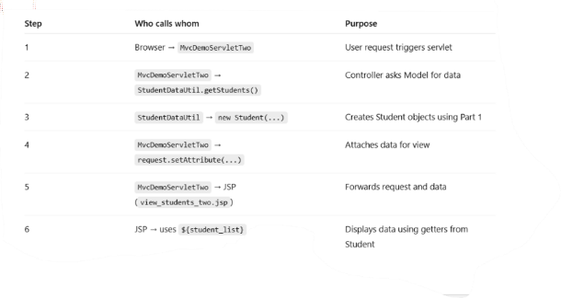**Code Flow:**

------------------************************************************************-----------------------

**Complete Project using JDBC – Part 1:** **Set Up Data Base Environment**

**Install MySQL Database on Windows:**

1. http://dev.mysql.com/downloads
2. Click “MySQL Community Server”
3. “**Windows (x86, 64-bit), MSI Installer”** 🡪 Download
4. Ignore Login/Signup 🡪 Click on “[**No thanks, just start my download.**](https://dev.mysql.com/get/Downloads/MySQL-9.5/mysql-9.5.0-winx64.msi)”
5. Go to Downloads 🡪 Open “mysql-9.5.0-winx64.msi”
6. Accept the license checkbox and click **Next**
7. Select “**Developer Default**” 🡪 Click **Next**
8. Select “**MySQL Workbench**” -> **Execute**
9. Follow instructions 🡪Click **Next** and **Finish**
10. If prompts for username & password: admin/admin
11. Enter password when prompts.
12. Click “**Check**” to check the connection 🡪 **Success**
13. Click Next
14. Select “**Start MySQL Workbench after setup**” 🡪 Click **Finish**

**Create SQL Scripts for application:**

1. Open **MySQL Workbench**
2. Go to File 🡪 **Open SQL Script**
3. Run the below scripts to **“Create new user”**

**(Note: Userid/Password: webstudent/ webstudent)**

**CREATE USER 'webstudent'@'localhost' IDENTIFIED BY 'webstudent';**

**GRANT ALL PRIVILEGES ON * . * TO 'webstudent'@'localhost';**

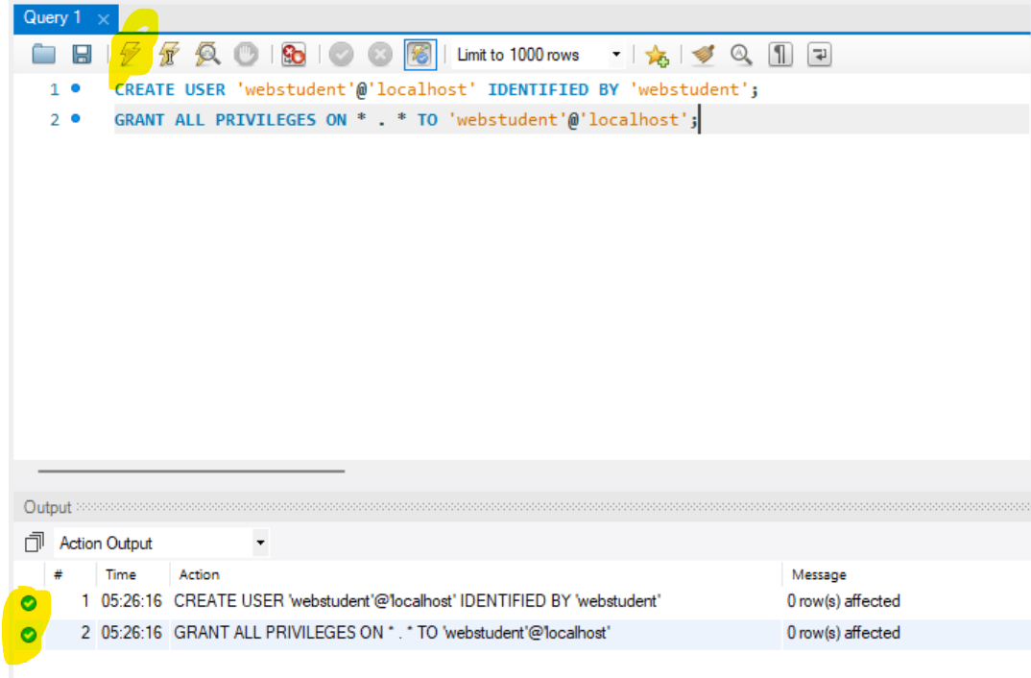

1. Create new database table: **Student** and load some sample data.
2. Run the student-tracker query.



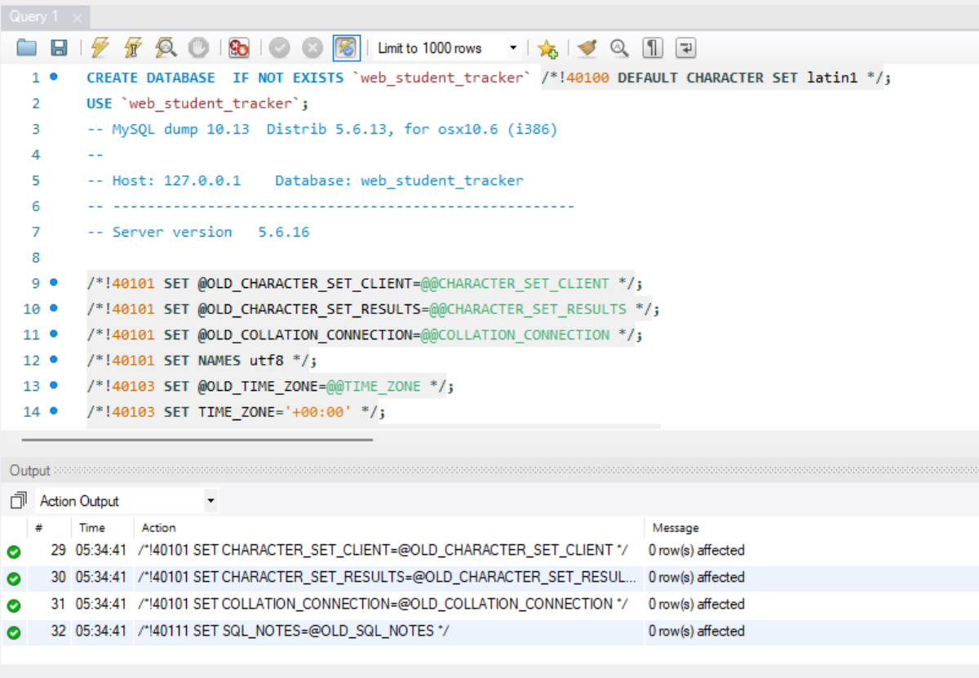

1. **Schema** 🡪Left side panel -> right click and Refresh all.

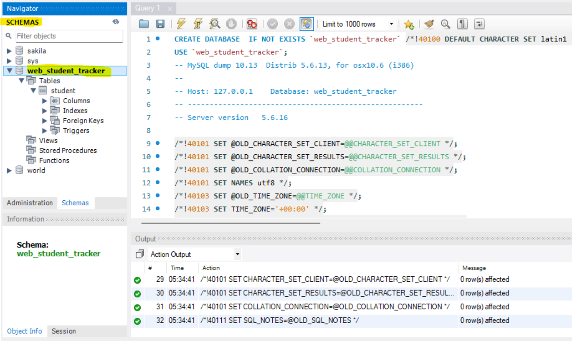

1. View inserted data 🡪 on **Student** table 🡪 right Click 🡪 **Select Rows**

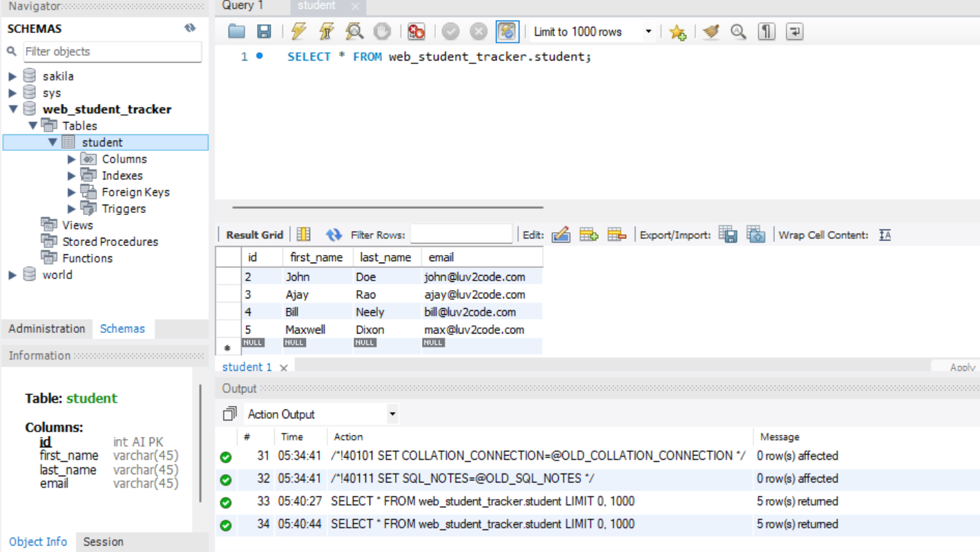

**Tomcat Data Source for connection Pooling:**

Step1:Download jar files for JDBC connection

<https://dev.mysql.com/get/Downloads/Connector-J/mysql-connector-java-8.0.13.zip>

Place the jar file 🡪 **WebContent/WEB-INF/lib**



Step2: Define Connection pool: **Context.xml**

File 🡪 **WebContent/META-INF**



<Context>

<Resource name="jdbc/web_student_tracker"

auth="Container" type="javax.sql.DataSource" **🡪 Connection Pool**

maxActive="20" maxIdle="5" maxWait="10000"

username="webstudent" password="webstudent"

driverClassName="com.mysql.cj.jdbc.Driver"

url="jdbc:mysql://localhost:3306/web_student_tracker?useSSL=false&amp;serverTimezone=UTC"/>

</Context>

**Test Tomcat Connection Pooling:**

Step 1:

Create new dynamic project

Project Name: **web-student-tracker**

Source folder “src”(remove 🡪 src/java/main)

Content Directory: **WebContent** 🡪 select checkbox 🡪 **generate web.xml** andClick **Finish**

Step 2:

Download jar files for JDBC connection

<https://dev.mysql.com/get/Downloads/Connector-J/mysql-connector-java-8.0.13.zip>

Place the jar file 🡪 **WebContent/WEB-INF/lib**

(Take the jar from the project location)

Step3:

Define Connection pool: **Context.xml**

File 🡪 **WebContent/META-INF**



<Context>

<Resource name="jdbc/web_student_tracker"

auth="Container" type="javax.sql.DataSource" **🡪 Connection Pool**

maxActive="20" maxIdle="5" maxWait="10000"

username="webstudent" password="webstudent"

driverClassName="com.mysql.cj.jdbc.Driver"

url="jdbc:mysql://localhost:3306/web_student_tracker "/>

</Context>

Step4: Write Code

1. Java Resource 🡪 Create package 🡪 Src 🡪 Package name: **com.demo.web.jdbc** 🡪 Finish
2. From Package “**com.demo.web.jdbc**” 🡪 New Servlet : **TestServlet** 🡪 Next 🡪 Next
3. Note:

Uncheck: Constructors from superclass

Uncheck: doPost

1. Click **Finish**
2. Write the attached code



1. TestServlet.java 🡪 Run on server

**MVC Architecture:**

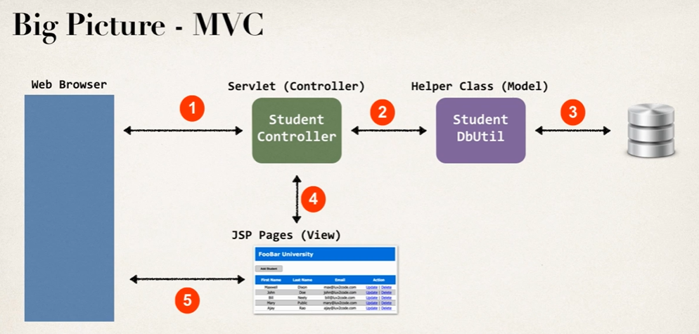

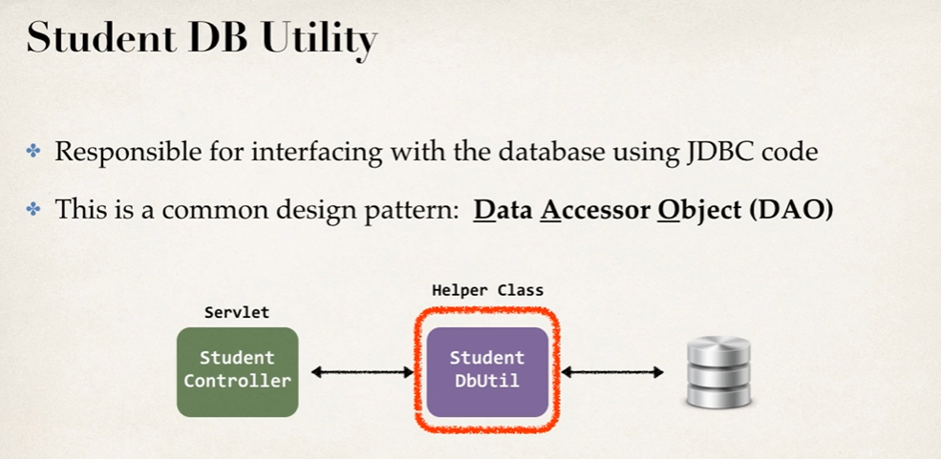

**Complete Project using JDBC – Part 2:**

**List Students**

**Existing Pre-requisites (Part 1):**

* Create new dynamic project, Project Name: **web-student-tracker**, Source folder “**src**”(remove 🡪 src/java/main),Content Directory: **WebContent**, Click Finish)
* Java Resources 🡪 src 🡪 new package : **com.demo.web.jdbc**

**Step1:**

Create new class: Java Resources 🡪 src 🡪 package -> New class : **Student.java**



package com.demo.web.jdbc;

public class Student {

private int id;

private String firstName;

private String lastName;

private String email;

public Student(String firstName, String lastName, String email) {

this.firstName = firstName;

this.lastName = lastName;

this.email = email;

}

public Student(int id, String firstName, String lastName, String email) {

this.id = id;

this.firstName = firstName;

this.lastName = lastName;

this.email = email;

}

public int getId() {

return id;

}

public void setId(int id) {

this.id = id;

}

public String getFirstName() {

return firstName;

}

public void setFirstName(String firstName) {

this.firstName = firstName;

}

public String getLastName() {

return lastName;

}

public void setLastName(String lastName) {

this.lastName = lastName;

}

public String getEmail() {

return email;

}

public void setEmail(String email) {

this.email = email;

}

@Override

public String toString() {

return "Student [id=" + id + ", firstName=" + firstName + ", lastName=" + lastName + ", email=" + email + "]";

}

}

**Step2:**

Create new class: Java Resources 🡪 src 🡪 package -> New class : **StudentDbUtil.java**



package com.demo.web.jdbc;

import java.sql.Connection;

import java.sql.PreparedStatement;

import java.sql.ResultSet;

import java.sql.Statement;

import java.util.ArrayList;

import java.util.List;

import javax.sql.DataSource;

public class StudentDbUtil {

private DataSource dataSource;

public StudentDbUtil(DataSource theDataSource) {

dataSource = theDataSource;

}

public List<Student> getStudents() throws Exception {

List<Student> students = new ArrayList<>();

Connection myConn = null;

Statement myStmt = null;

ResultSet myRs = null;

try {

// get a connection

myConn = dataSource.getConnection();

// create sql statement

String sql = "select * from student order by last_name";

myStmt = myConn.createStatement();

// execute query

myRs = myStmt.executeQuery(sql);

// process result set

while (myRs.next()) {

// retrieve data from result set row

int id = myRs.getInt("id");

String firstName = myRs.getString("first_name");

String lastName = myRs.getString("last_name");

String email = myRs.getString("email");

// create new student object

Student tempStudent = new Student(id, firstName, lastName, email);

// add it to the list of students

students.add(tempStudent);

}

return students;

}

finally {

// close JDBC objects

close(myConn, myStmt, myRs);

}

}

private void close(Connection myConn, Statement myStmt, ResultSet myRs) {

try {

if (myRs != null) {

myRs.close();

}

if (myStmt != null) {

myStmt.close();

}

if (myConn != null) {

myConn.close(); // doesn't really close it ... just puts back in connection pool

} }

catch (Exception exc) {

exc.printStackTrace();

} } }

**Step3:**

Create new class: Java Resources 🡪 src 🡪 package -> New class : **StudentControllerServlet.java**

Note:

Uncheck: Constructors from superclass

Uncheck: doPost



package com.demo.web.jdbc;

import java.io.IOException;

import java.util.List;

import javax.annotation.Resource;

import javax.servlet.RequestDispatcher;

import javax.servlet.ServletException;

import javax.servlet.annotation.WebServlet;

import javax.servlet.http.HttpServlet;

import javax.servlet.http.HttpServletRequest;

import javax.servlet.http.HttpServletResponse;

import javax.sql.DataSource;

/**

* Servlet implementation class StudentControllerServlet

*/

@WebServlet("/StudentControllerServlet")

public class StudentControllerServlet extends HttpServlet {

private static final long serialVersionUID = 1L;

private StudentDbUtil studentDbUtil;

@Resource(name="jdbc/web_student_tracker")

private DataSource dataSource;

//Source 🡪 Override/Implements methods

@Override

public void init() throws ServletException {

super.init();

// create our student db util ... and pass in the conn pool / datasource

try {

studentDbUtil = new StudentDbUtil(dataSource);

}

catch (Exception exc) {

throw new ServletException(exc);

}

}

protected void doGet(HttpServletRequest request, HttpServletResponse response) throws ServletException, IOException {

// list the students ... in mvc fashion

**try** {

listStudents(request, response);

} **catch** (Exception e) {

// **TODO** Auto-generated catch block

e.printStackTrace();

}

}

private void listStudents(HttpServletRequest request, HttpServletResponse response)

throws Exception {

// get students from db util

List<Student> students = studentDbUtil.getStudents();

// add students to the request

request.setAttribute("STUDENT_LIST", students);

// send to JSP page (view)

RequestDispatcher dispatcher = request.getRequestDispatcher("/list-students.jsp");

dispatcher.forward(request, response);

} }

**Step4:**

Create new jsp: WebContent 🡪 New File : **list_students.jsp**



<%@ page import="java.util.*, com.luv2code.web.jdbc.*" %>

<!DOCTYPE html>

<html>

<head>

<title>Student Tracker App</title>

<link type=”text/css” rel=”stylesheet” href=”css/style.css”>

</head>

<%

// get the students from the request object (sent by servlet)

List<Student> theStudents =

(List<Student>) request.getAttribute("STUDENT_LIST");

%>

<body>

<div id="wrapper">

<div id="header">

<h2>Advanced Java University</h2>

</div>

</div>

<div id="container">

<div id="content">

<table>

<tr>

<th>First Name</th>

<th>Last Name</th>

<th>Email</th>

</tr>

<% for (Student tempStudent : theStudents) { %>

<tr>

<td> <%= tempStudent.getFirstName() %> </td>

<td> <%= tempStudent.getLastName() %> </td>

<td> <%= tempStudent.getEmail() %> </td>

</tr>

<% } %>

</table>

</div>

</div>

</body>

</html>

**Step5:**

Create new css: WebContent 🡪 New Folder : css 🡪 import or copy paste : **style.css**



html, body{

margin-left:15px; margin-right:15px;

padding:0px;

font-family:Verdana, Arial, Helvetica, sans-serif;

}

table {

border-collapse:collapse;

border-bottom:1px solid gray;

font-family: Tahoma,Verdana,Segoe,sans-serif;

width:72%;

}

th {

border-bottom:1px solid gray;

background:none repeat scroll 0 0 #0775d3;

padding:10px;

color: #FFFFFF;

}

tr {

border-top:1px solid gray;

text-align:center;

}

tr:nth-child(even) {background: #FFFFFF}

tr:nth-child(odd) {background: #BBBBBB}

#wrapper {width: 100%; margin-top: 0px; }

#header {width: 72%; background: #0775d3; margin-top: 0px; padding:15px 0px 15px 0px;}

#header h2 {width: 100%; margin:auto; color: #FFFFFF;}

#container {width: 100%; margin:auto}

#container h3 {color: #000;}

#container #content {margin-top: 20px;}

.add-student-button {

border: 1px solid #666;

border-radius: 5px;

padding: 4px;

font-size: 12px;

font-weight: bold;

width: 120px;

padding: 5px 10px;

margin-bottom: 15px;

background: #cccccc;

}

**Step6:**

Create new jsp: WebContent 🡪 New Folder : css 🡪 import or copy paste : **style.css**

Place the **jstl jar** files 🡪 **WebContent/WEB-INF/lib**



Replace the JSP Scriptlet codes with JSTL tags

* Remove the import packages line
* Add taglib uri
* Delete the JSP scriptlets **List<student> the students (line 12 to 16)** in jsp file**.**
* Delete the normal for loop to **<c:forEach> (line 12 to 16)** in jsp file “**list_students.jsp**”**.**



<%@ taglib uri="http://java.sun.com/jsp/jstl/core" prefix="c" %>

<!DOCTYPE html>

<html>

<head>

<title>Student Tracker App</title>

<link type="text/css" rel="stylesheet" href="css/style.css">

</head>

<body>

<div id="wrapper">

<div id="header">

<h2>FooBar University</h2>

</div>

</div>

<div id="container">

<div id="content">

<table>

<tr>

<th>First Name</th>

<th>Last Name</th>

<th>Email</th>

</tr>

<c:forEach var="tempStudent" items="${STUDENT_LIST}">

<tr>

<td> ${tempStudent.firstName} </td>

<td> ${tempStudent.lastName} </td>

<td> ${tempStudent.email} </td>

</tr>

</c:forEach>

</table>

</div>

</div>

</body>

</html>

**Step7:**

1. Place the **web.xml** file 🡪 **WebContent/WEB-INF**
2. Restart the tomcat if any changes to **web.xml**



<?xml version="1.0" encoding="UTF-8"?>

<web-app xmlns:xsi="http://www.w3.org/2001/XMLSchema-instance" xmlns="http://xmlns.jcp.org/xml/ns/javaee" xsi:schemaLocation="http://xmlns.jcp.org/xml/ns/javaee http://xmlns.jcp.org/xml/ns/javaee/web-app_3_1.xsd" id="WebApp_ID" version="3.1">

<display-name>web-student-tracker-solution</display-name>

<welcome-file-list>

<welcome-file>StudentControllerServlet</welcome-file>

<welcome-file>index.jsp</welcome-file>

<welcome-file>index.html</welcome-file>

</welcome-file-list>

</web-app>

1. Create new html file: WebContent 🡪 New File : **index.html**

<html>

<body>

<h1>Hello Brave New World!</h1>

</body>

</html>

**Complete Project using JDBC – Part 3:**

**Add Students**

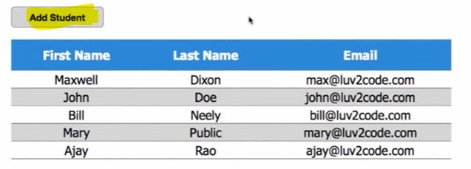

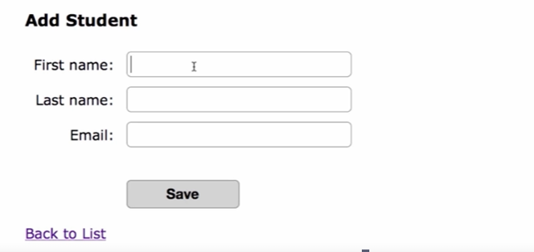

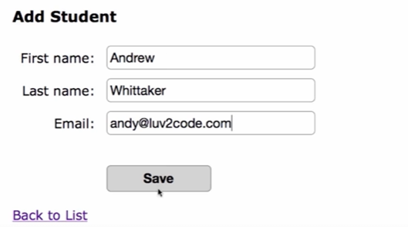

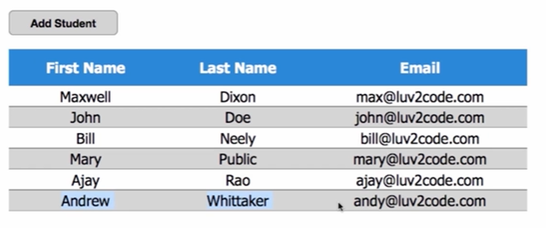

**Flow:**

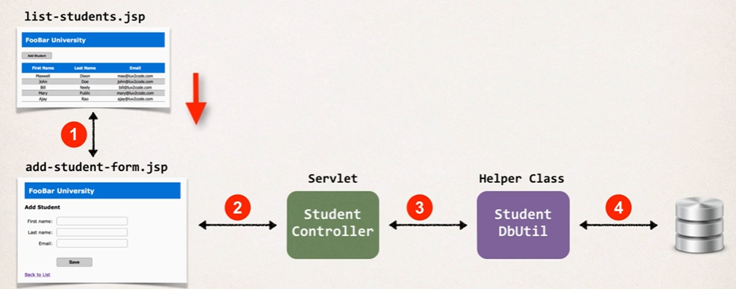

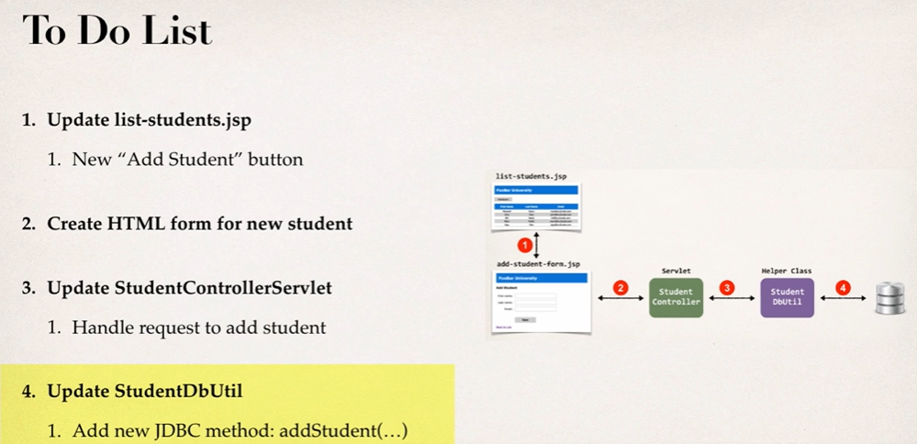

**Step1:**

**Setting up the “Add Student” button**

Open Project 🡪 Open the JSP file : **list_students.jsp**



<!-- put new button: Add Student -->

<input type="button" value="Add Student"

onclick="window.location.href='add-student-form.jsp'; return false;"

class="add-student-button"

/>

**Step2:**

Create new css: WebContent 🡪 Existing Folder : css 🡪 import or copy paste : **add-student-style.css**



Open Project: **web-student-tracker** 🡪 Create new jsp: WebContent 🡪 New File : **add-student-form.jsp**



**Step3:**

Update: Java Resources 🡪 src 🡪 package -> class : **StudentControllerServlet.java**



* Use Switch Case to List, Add students.
* Create addstudents()

**Step4:**

Update: Java Resources 🡪 src 🡪 package -> class : **StudentdbUtil.java**



**Complete Project using JDBC – Part 4:**

**Update Students**

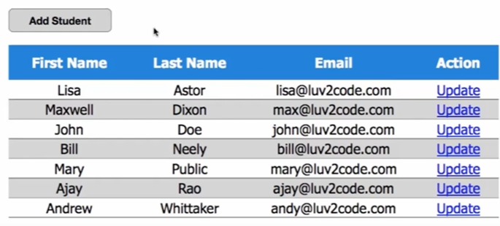

Data is prepopulated.

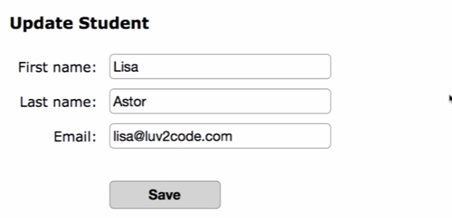

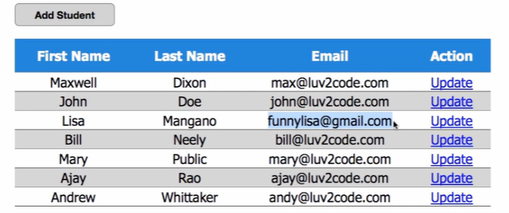

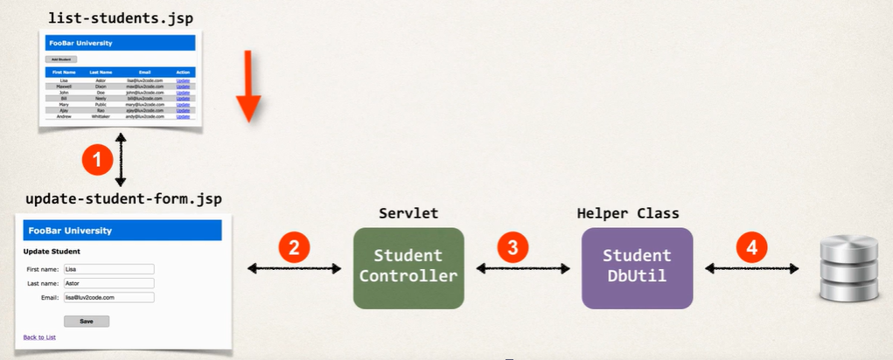

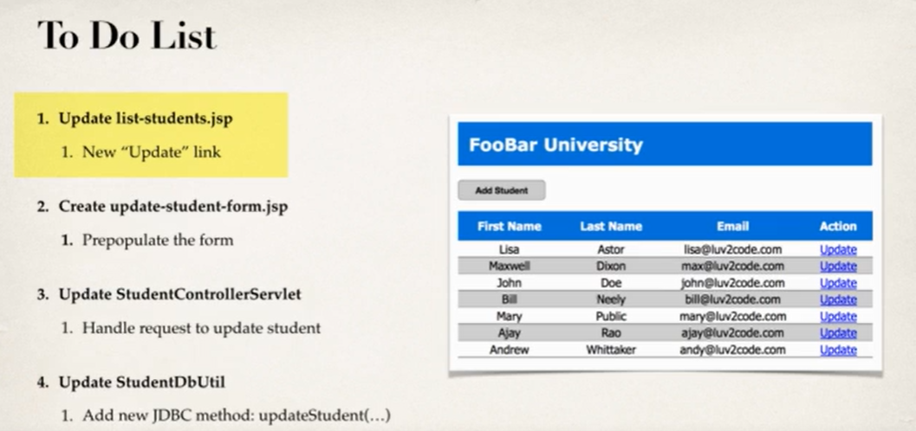

**Step1:**

Creating the Update link

Open Project 🡪 Open the JSP file : **list_students.jsp**



<!-- set up a link for each student -->

<c:url var="tempLink" value="StudentControllerServlet">

<c:param name="command" value="LOAD" />

<c:param name="studentId" value="${tempStudent.id}" />

</c:url>

<td>

<a href="${tempLink}">Update</a>

</td>

**Step2:**

Update: Java Resources 🡪 src 🡪 package -> class : **StudentControllerServlet.java**



* Use Switch Case to Load
* Create loadStudent ()
* Create getstudent() in s **StudentdbUtil.java**

**Step3:**

Update: Java Resources 🡪 src 🡪 package -> class : **StudentdbUtil.java**



* getStudent(String theStudentID) method is created

**Step4:**

Pre-populate the data in **update-student-form.jsp**

Open Project: **web-student-tracker** 🡪 Create new jsp: WebContent 🡪 New File : **update-student-form.jsp**



**Step5:**



Update: Java Resources 🡪 src 🡪 package -> class : **StudentControllerServlet.java**

* **update-student-form.jsp** uses **“type = hidden”** (line 23 & 25) 🡪 why? For Update functionality
* Use Switch Case to Upload
* Create UpdateStudent ()
* Create updatestudent() in s **StudentdbUtil.java**

**Step6:**

* Update: Java Resources 🡪 src 🡪 package -> class : **StudentdbUtil.java**



**Complete Project using JDBC – Part 5:**

**Delete Students**

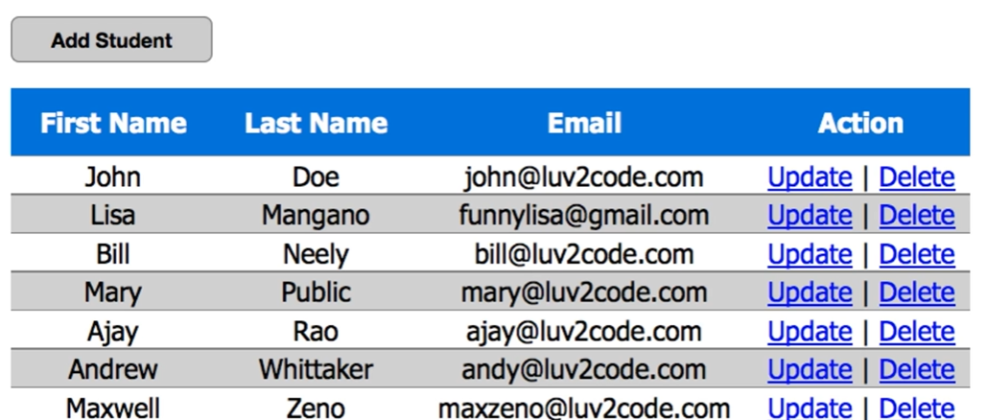 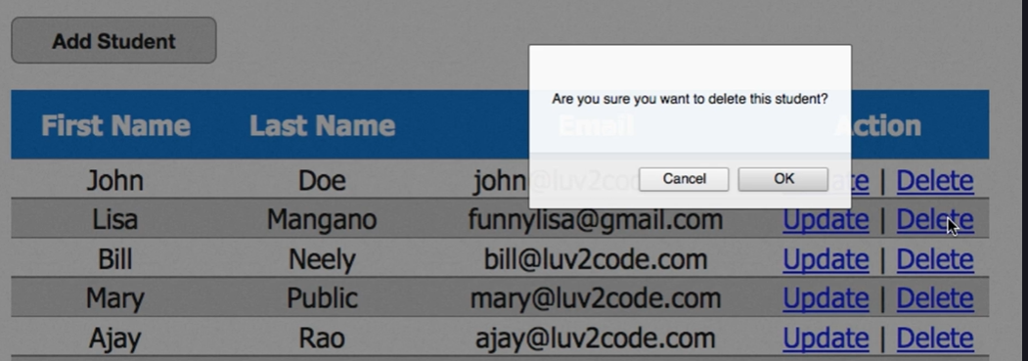 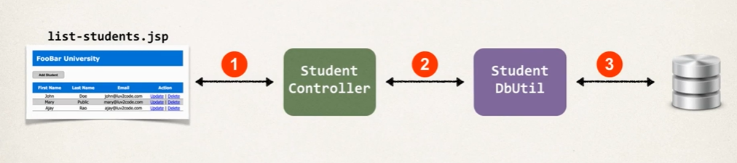 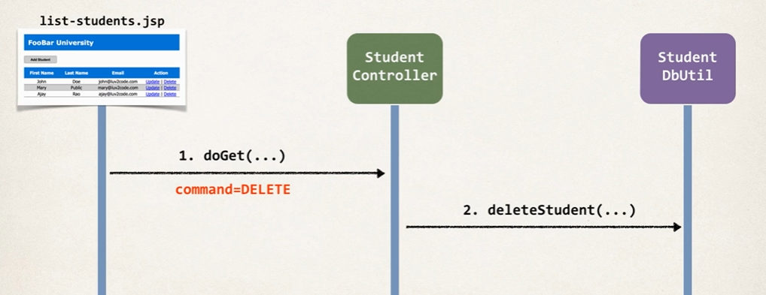

**Step1:**

Creating the Delete link

Open Project 🡪 Open the JSP file : **list_students.jsp**



**Step2:**

Update: Java Resources 🡪 src 🡪 package -> class : **StudentControllerServlet.java**



* Use Switch Case to Dalete
* Create DeleteStudent ()
* Create DeleteStudent() in s **StudentdbUtil.java**

**Step3:**

Update: Java Resources 🡪 src 🡪 package -> class : **StudentdbUtil.java**



* deleteStudent(String theStudentID) method is created